Gotta Love a bit a Wozza!

I wrote last eletter about the upcoming Australian Open and I have been diligently following, betting and trading in the Aussie Open this week. Yes a midnight start is a little taxing but boy have there been some superb examples showing the points I made in the last eletter.

And there is no better example than our Wozza.

Better known to you, I am sure, as Caroline Wozniacki.

It was the 17th January 2018 and our Wozza, as she will be known from now on, was a 1.04 shot to beat J . Fett ( who?) .

This is World Number 2 versus World Number 119th.

A 1.04 shot needs £100 bet in order to win £4. In horse racing parlance, you could say our Wozza was ‘warm order’.

If you would like to see the match unravel point-by-point, I would recommend you check out the match at [www.flashscore.com/tennis/](http://www.flashscore.com/tennis/) , find the match for 17th January and click on it.

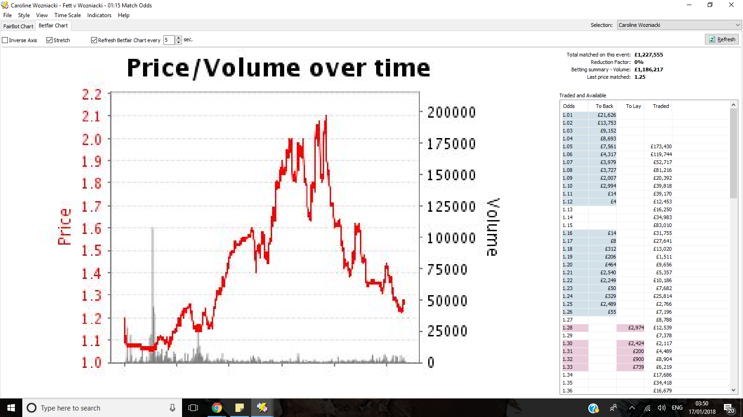

This is the first point. Our Wozza lost the first set. This 1.04 shot could be backed at 2.1 odds ( just over evens)

But hang on , it gets better ( no Wozza did not ask me to marry her!). Wozza wins the 2nd set. It is in the 3rd set that things get exciting.

Let me take you through the games sequence in the 3rd set. The first number represents Fett. The second number is our Wozza’s score.

1-0

1-1

2-1

3-1

4-1

5-1

Yes, Fett ( who the feck is she?) is 5-1 up in the deciding set against World Number 2!

During that potential match game Fett was 30-0 on serve, serving for the match!

It is here that you back our Wozza who simply is in deep doo-doo and needs to wriggle out.

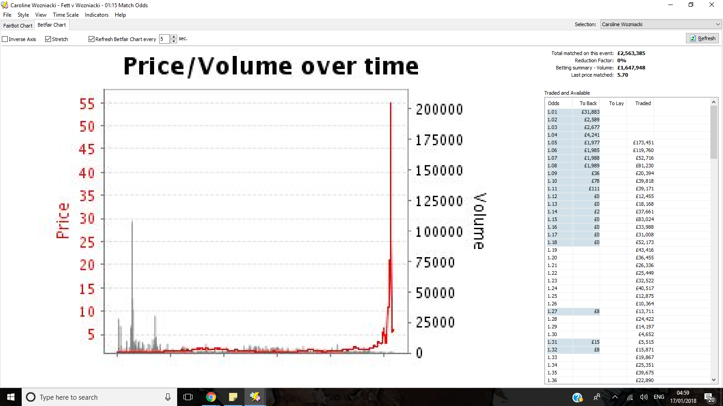

Our Wozza was 1.04 odds pre match, and at this very point was backable at odds of 55. Talk about post-Christmas Presents.

Let me continue this potential decider set

5-2 ( Wozza won that crucial game having to break serve)

5-3

5-4

5-5

5-6

5-7

This is Roy of the Rovers stuff ! And this is where and how you can back a World Number 2 at odds of 55 , and win!!

I have many other examples from this weeks of players who hit 12/1 and higher and went on to win, or at least their odds dropped significantly enough for us to profit by ‘cashing out’ in play.

Do get to know [www.flashscore.com/tennis/](http://www.flashscore.com/tennis/) and look at some of the games before they disappear. Look for short odds favourites( click on the match link to see the pre-match odds).

You will be amazed, in Grand Slam tennis more than any other, how often strong favourites struggle and look like losing against players who we have never even heard of!