The reliability of top ranked players

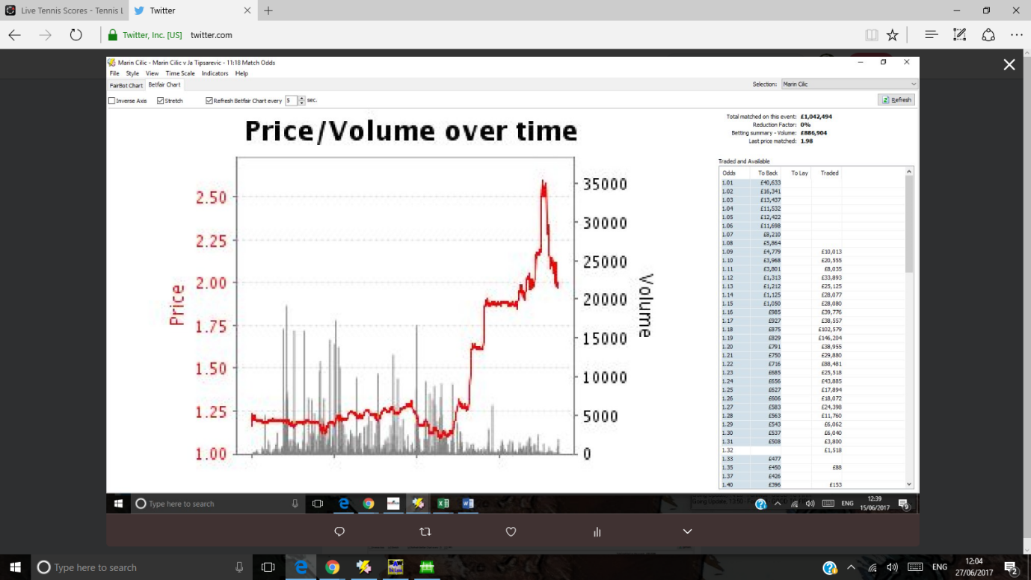

June 15th Cilic v Tipsarevic

Cilic

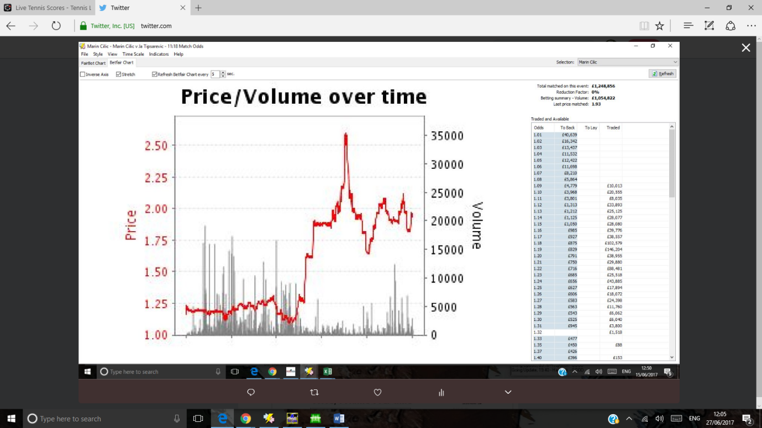

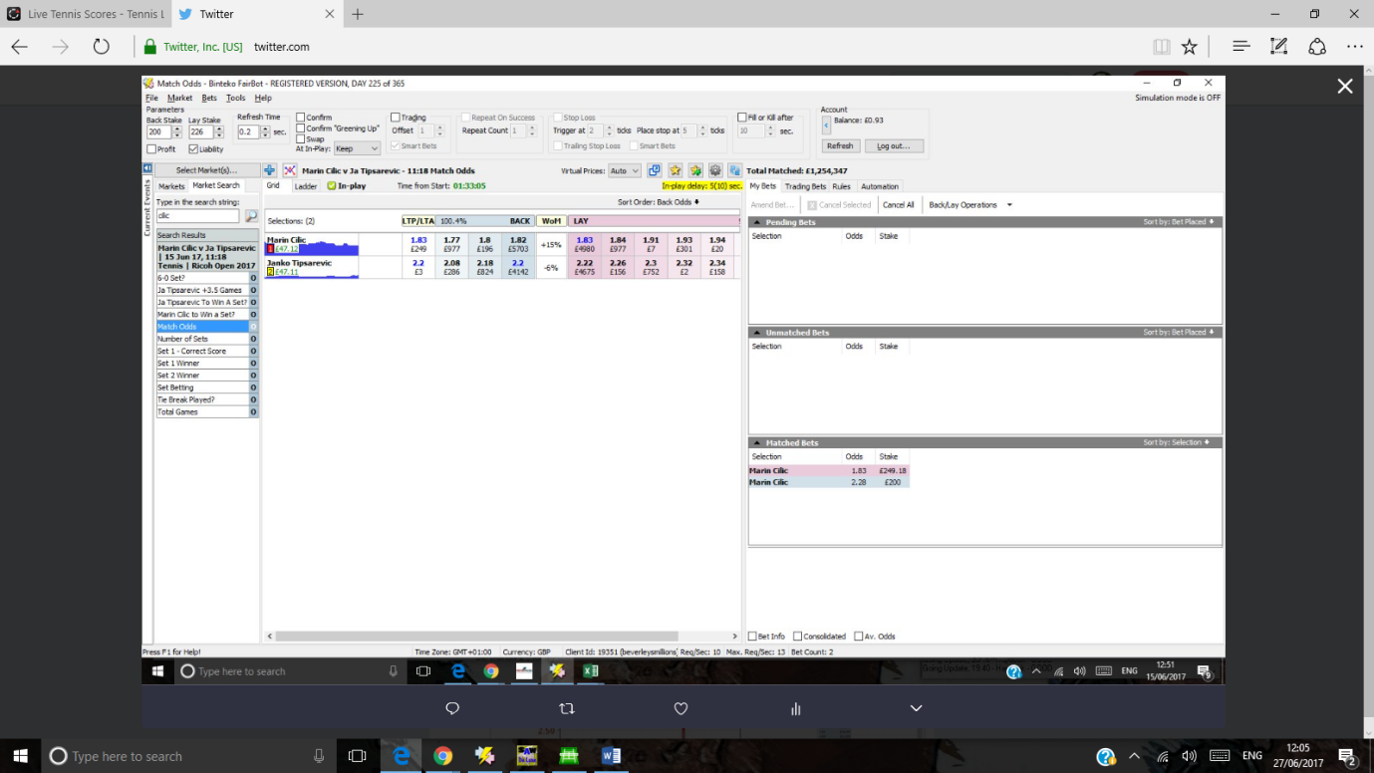

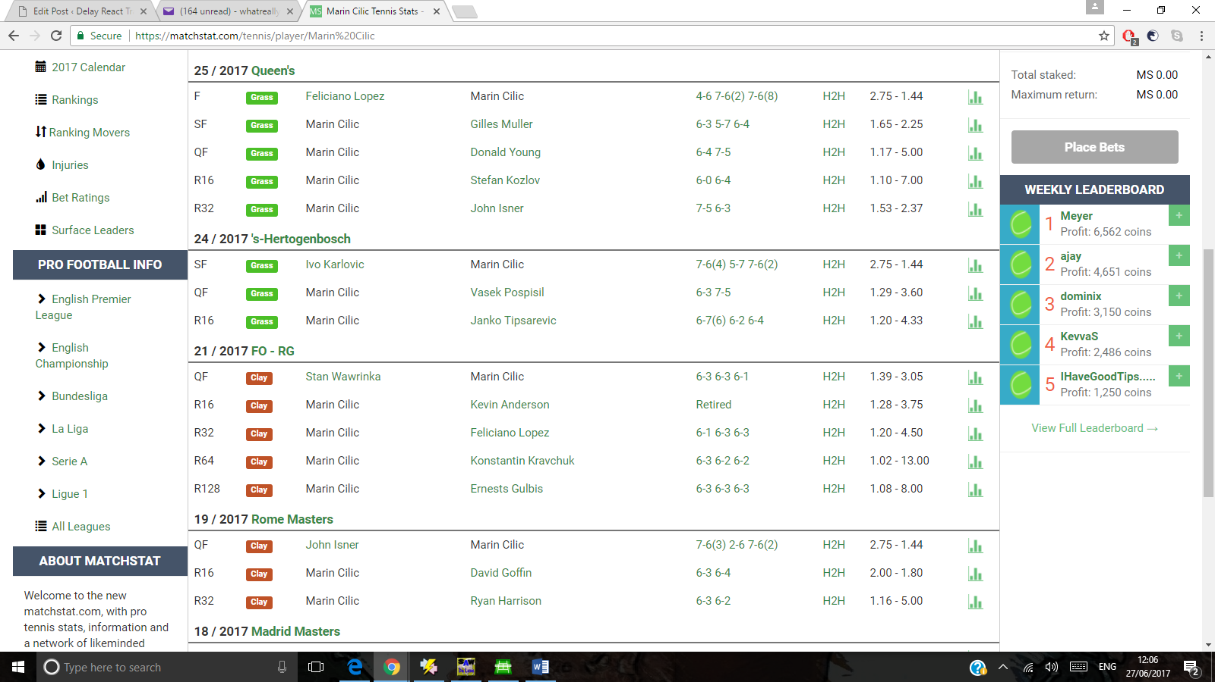

The first set was won by Tipsarevic in a tie breaker. Note Cilic was 1.2 pre match. Cilic, at time of writing, has an air of reliability about him and is enticing to back at 2.00 ( evens).

This is the kind of simplistic trade which you should be searching for.