Know your players
When you start to research and trade tennis on a more frequent basis, you get to know the character of some of the players. Here is a quick off-the-cuff list of a few standout tennis players, for me, along with their primary characteristics
- David Ferrer. Terrier. Will always give 100% . Back if losing first set
- Francesca Schiavone. Like Ferrer, a fighter and totally committed
- Caroline Wozniacki. Does not know when she is beaten.
- John Isner – big server. Tie break specialist.
- Ivo Karlovic – big server. Tie break specialist. Will open the door for opponents. Tends to be easily broken by top 20 ranked players.
- Kei Nishikori. Tendency to injure
- Del Potro – comes and goes in waves. World Class when on song, but prone to injuries and niggles and can suddenly throw in a wobbler.
- Djokovic – more vulnerable now than he has ever been
- Lopez – solid on grass
- Muller – solid on grass
- Nadal – unlikely to drop a set on a clay court if fully fit.
- Dolgopolov – unpredictable
- Kyrgios – mentally weak. Has thrown matches
These are the primary characteristics I assign to these players. Generally the list above is a reliable list. I will, for instance, leave all Kyrgios matches alone or at best lay him if his odds are short enough.
I have profited well during the grass season in following Gilles Muller and Feliciano Lopez.
So let me take you through a few ‘know your players’ games. The names will be familiar, as will the reasons why I traded in these matches.

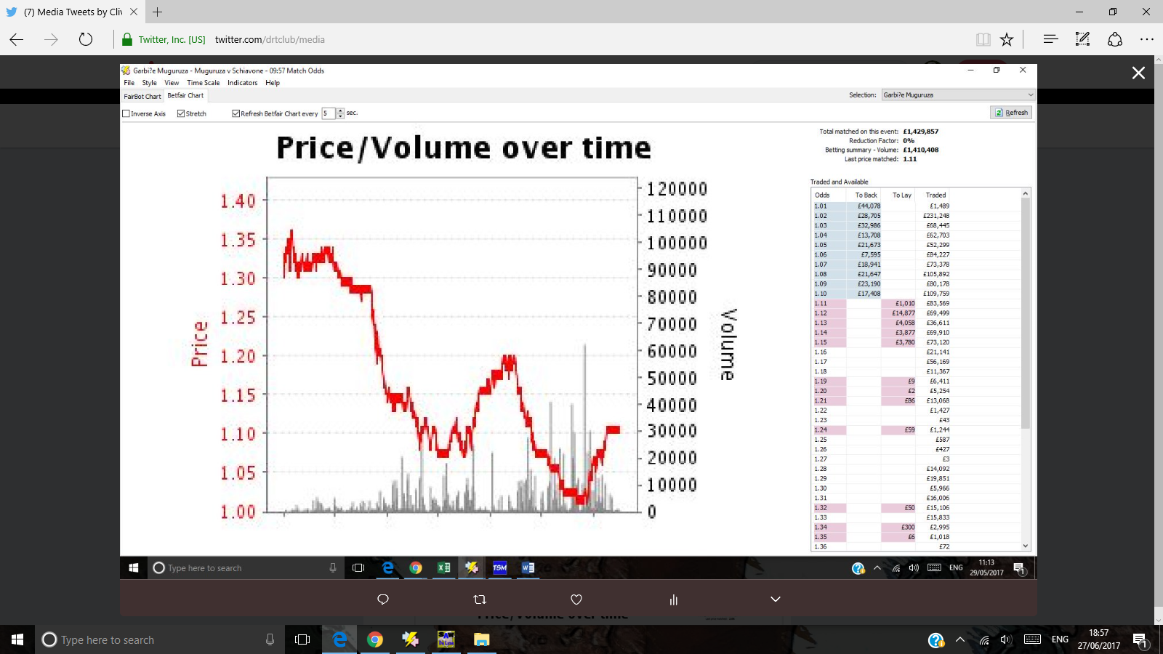
It’s May 29th 2017. Garbine Muguruza is playing Francesca Schiavone. It’s the French Open and Garbine is 1.3 favourite. She wins the first set 6-2
The scoreline is 4-2 in the second set. I tweet the following advice
‘Lay at 1.03 is a lay to nothing. Schiavone has a reputation as a battler.’
The fight back begins as you can see from the graph.

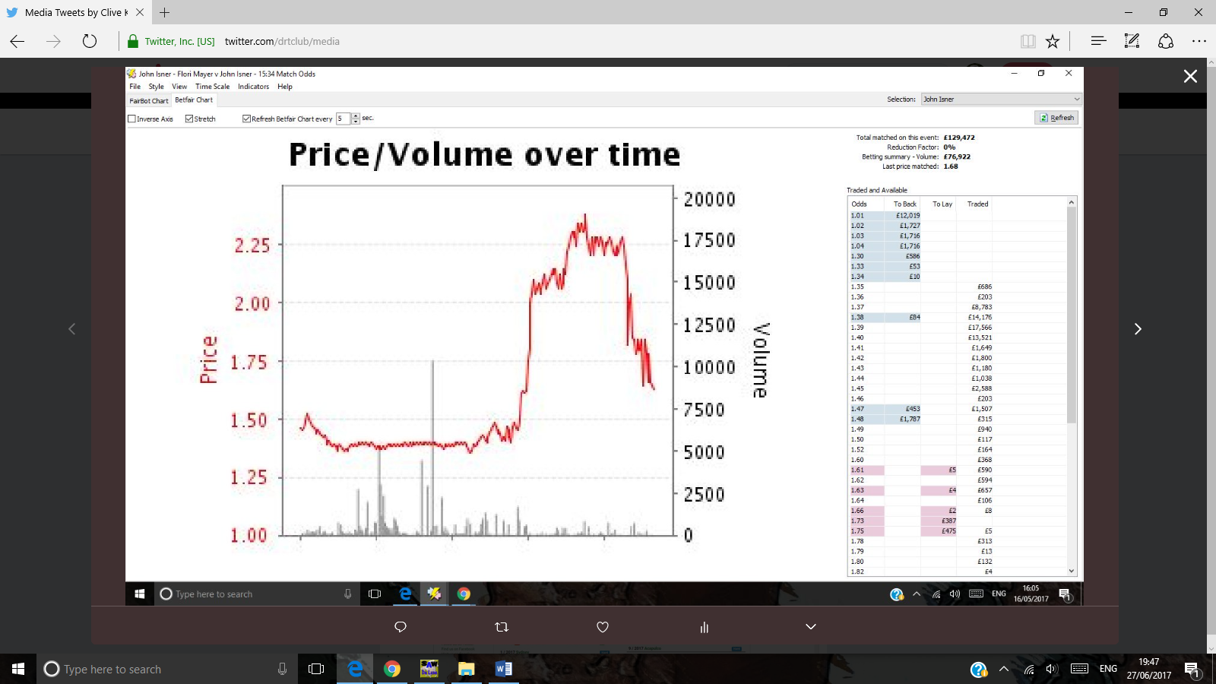
It’s May 16th. Florian Mayer is playing John Isner. Strong favourite John Isner looks as if he is going to lose the first set. We know that John is a tie breaker player so his opponent can always be allowed in with a chance. We back Isner at a high of 2.25 and he averts disaster, winning the first set 7-6 and winning the second set 7-6.

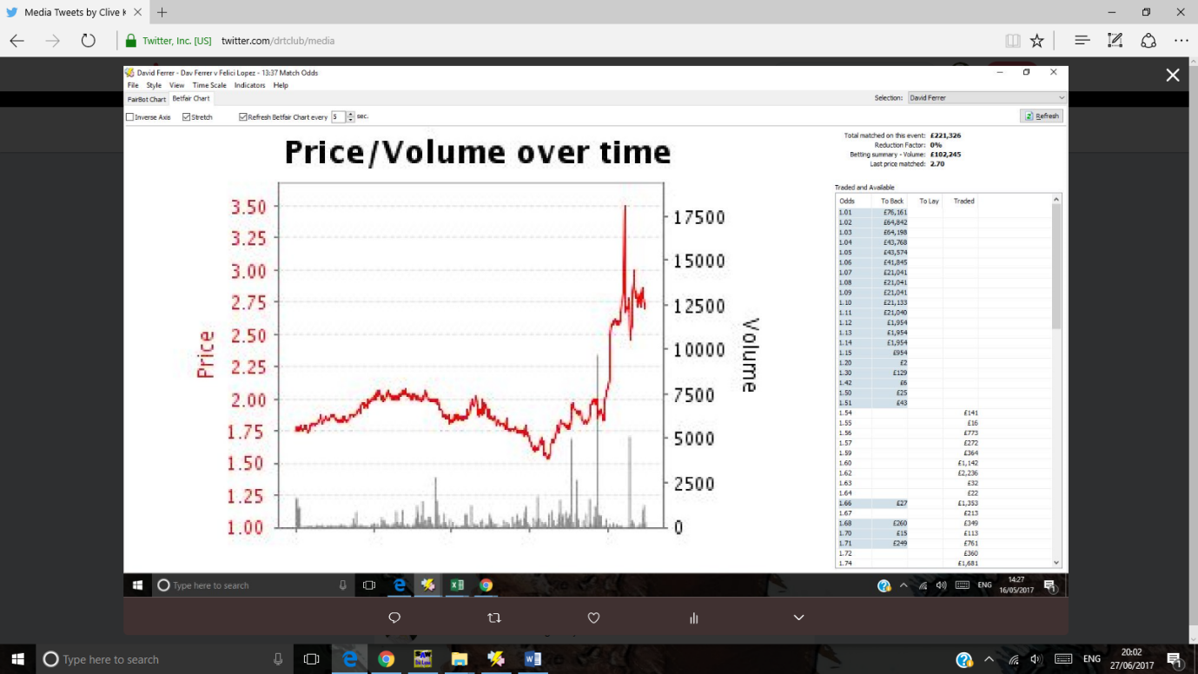
- Clive Keeling‏Protected Tweets @drtclub May 16
More

Ferrer - the terrier - twilight of his career. Thought he would win first set but drifting now. He will battle 2nd set if losing first.
Wozniacki the street fighter
At 1.75 odds pre-match, the market is telling us that Caroline Wozniacki’s match with Anett Kontaveit is her trickiest match to date at Wimbledon.
Wozniacki loses the first set. I tweet this advice
‘3.05 backing Wozza despite the market telling us this is her toughest encounter to date. this is the Wozza of old and I will risk it’
July 8^{th’}
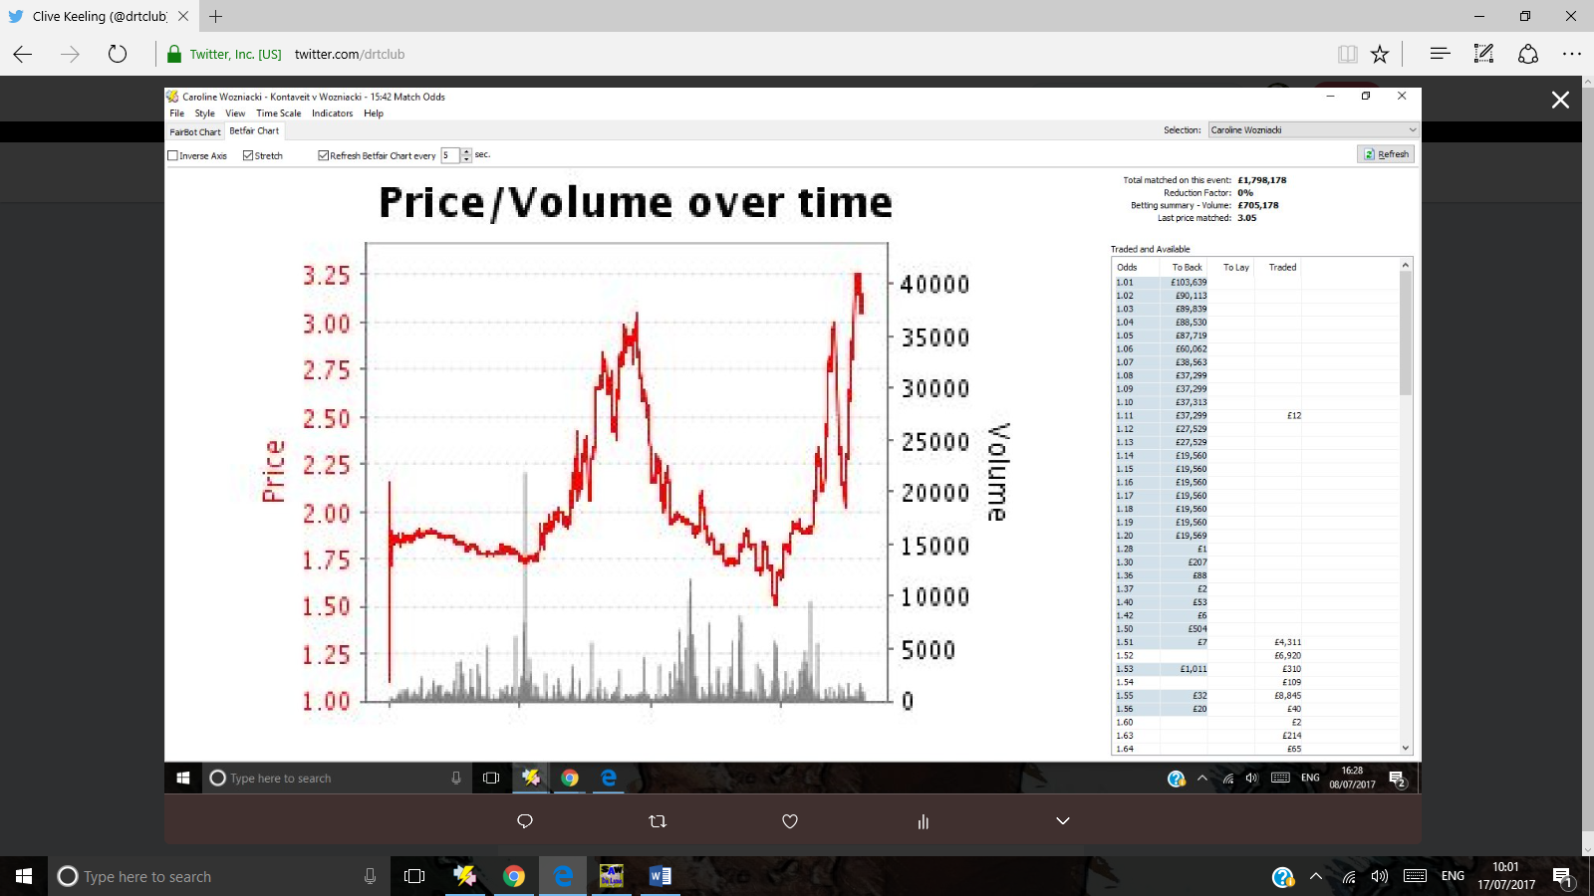
We see the street fighting . Wozniacki’s odds hit a high of 3.00. She fights back until her odds hit a low of 1.5. She gets in even more trouble and her odds exceed the 3.00 from earlier.
In fact, the second set is a battle for Wozniacki. Here is the story of the match in graph format.
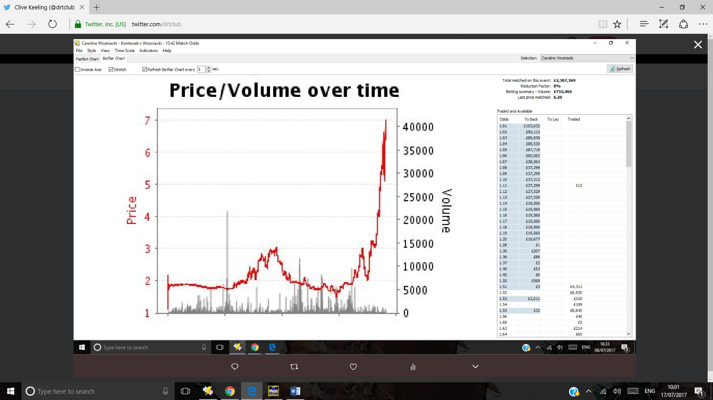
The section of the graph you see highlighted in orange above is the section you see on the original graph.
It looks as if Caroline is in danger of losing this match in straight sets.
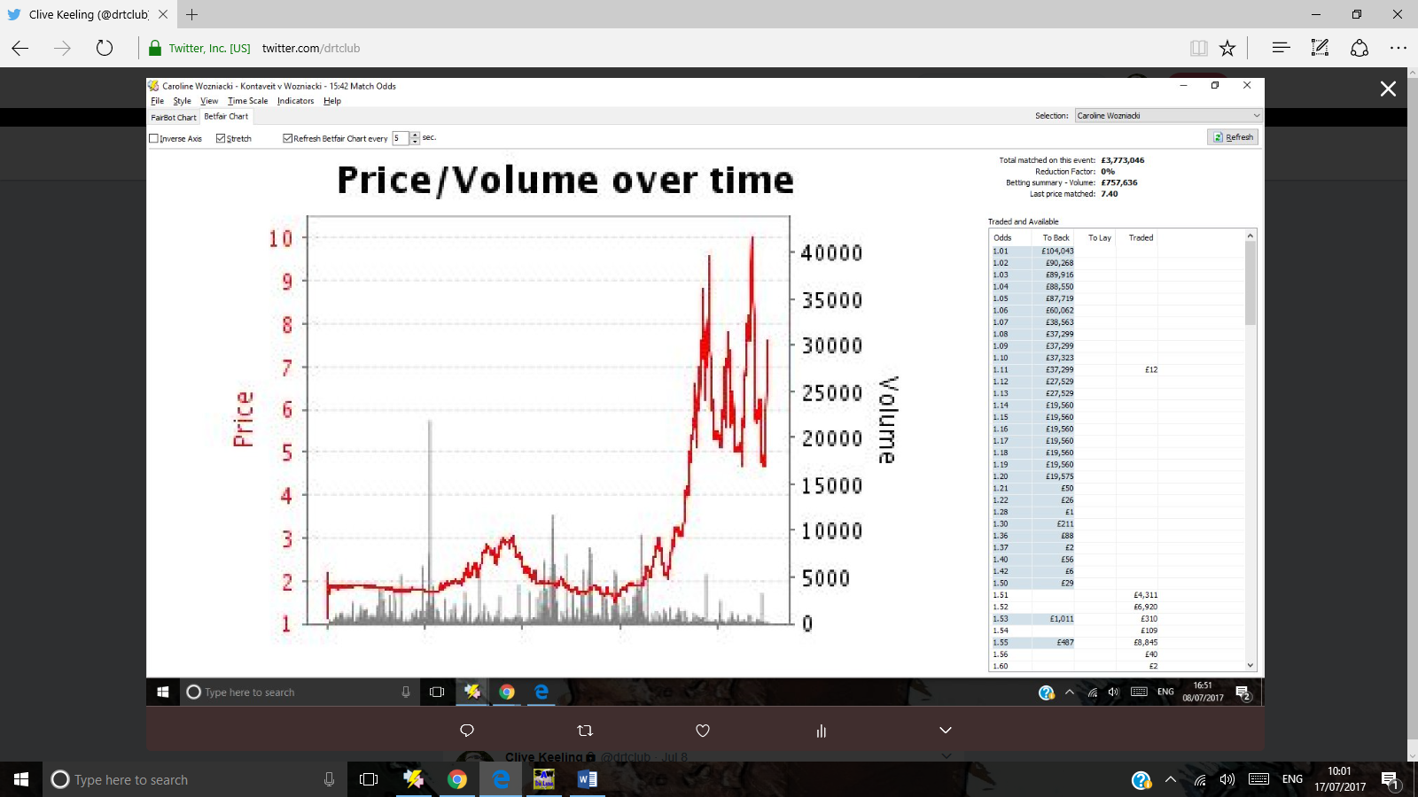
Wozniacki’s odds flirt with the 10.00 odds marker. But she is a fighter. Consistently she fights back, once down to 5, then back to 8, then back to 5, then up to 10, then back to 5 – trading blows with Kontaveit and fighting for this second set.
We know our player. We know Wozniacki is a fighter so we can back her at her highest point, hope she absorbs the punches and wins the second ‘round’.
After a heavyweight tussle, Wozniacki wins through in the second set on a tie breaker.

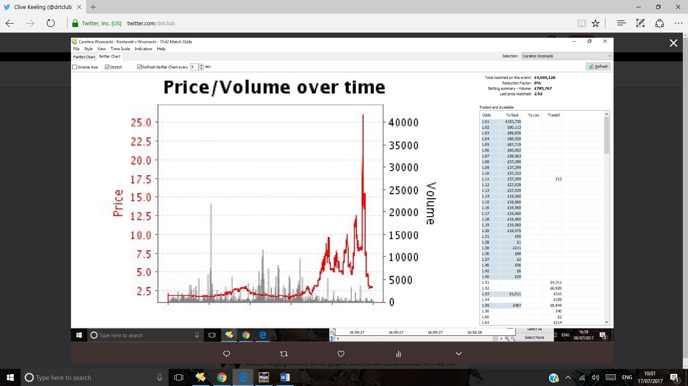
The market had written her off at odds as high as 25. But we know….she will battle on and soon her odds plummit to near 2.5
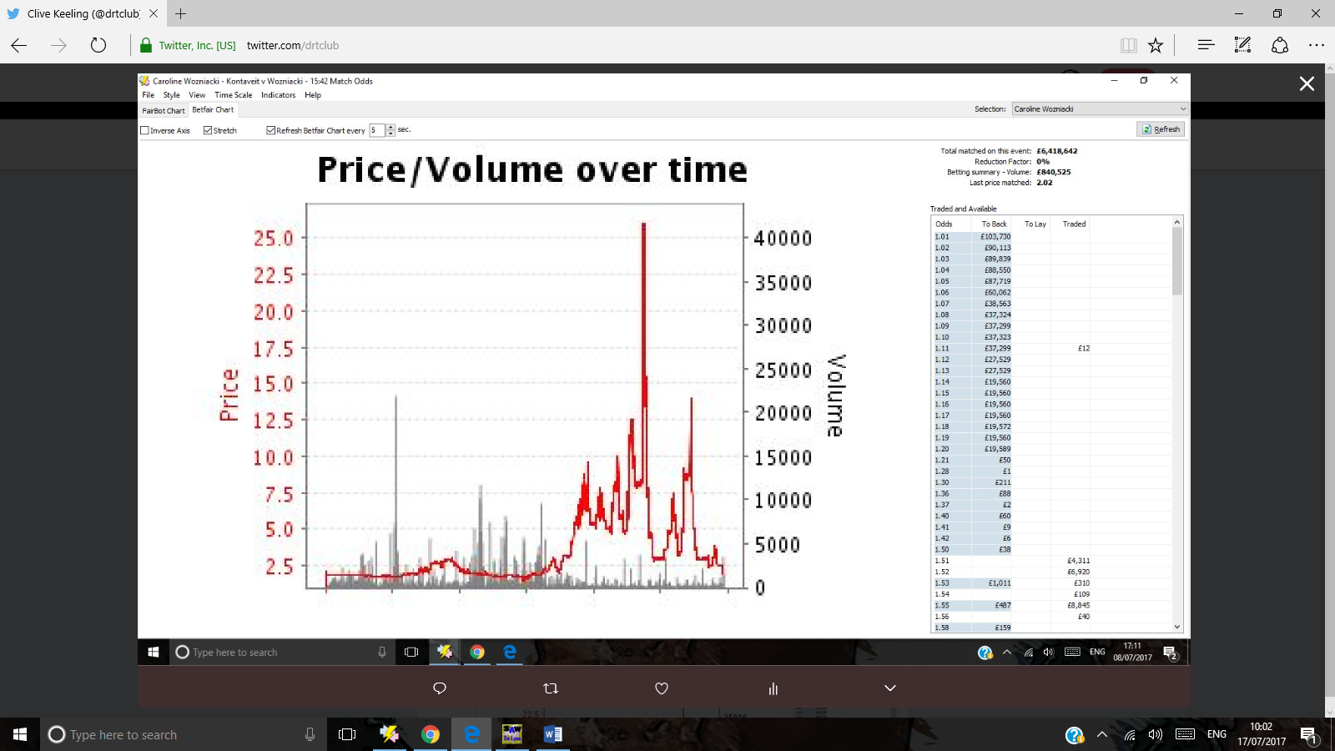
I backed Caroline at modest odds of 6.6 and traded out at odds of 2.02. She was as high as 25, when her nose was bloodied and those knees were knocking.

Back based on the ranking – Kerber
Angelique Kerber is a World Number One who seems to be back on the road to recovery after injury. 1st v 28th in the World and only the 3rd round into Wimbledon.
Kerber loses the first set. In this instance we know she is still World Number 1 and playing in a Grand Slam ( Wimbledon)
- Clive Keeling‏Protected Tweets @drtclub Jul 8
More

Backed 4.7, odds now 2.3 Ker ching. But I did not get the 8 on offer for Angelique
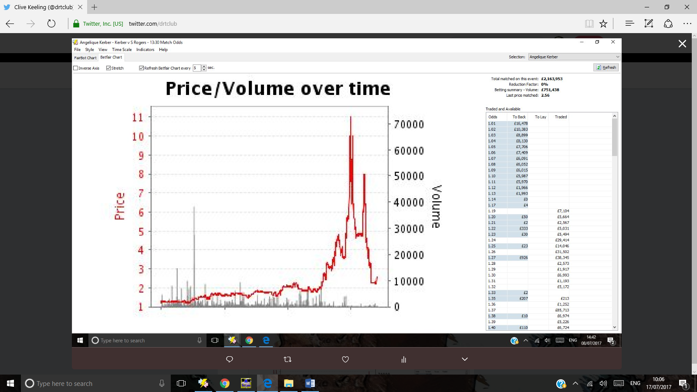
Rather like Wozniacki, Kerber needed to win that 2nd set but struggled terribly. The market gave up on her, quoting this World Number 1 at odds of 11 at her highest. Kerber won the 2nd set in a tie breaker and won the match.
- Clive Keeling‏Protected Tweets @drtclub Jul 6
More

1.76 tempts me in to backing Thiem as long as he does not capitulate as he did in Turkey. He tends to beat SImon in 2017 head to heads
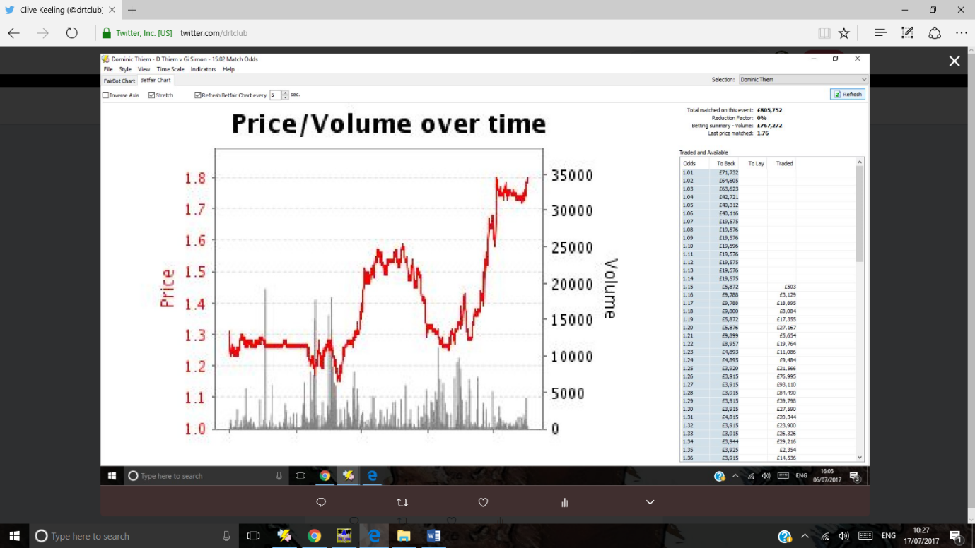

- Clive Keeling‏Protected Tweets @drtclub Jul 5
More

1.7 High Kvitova will get lower if she saves this service game.
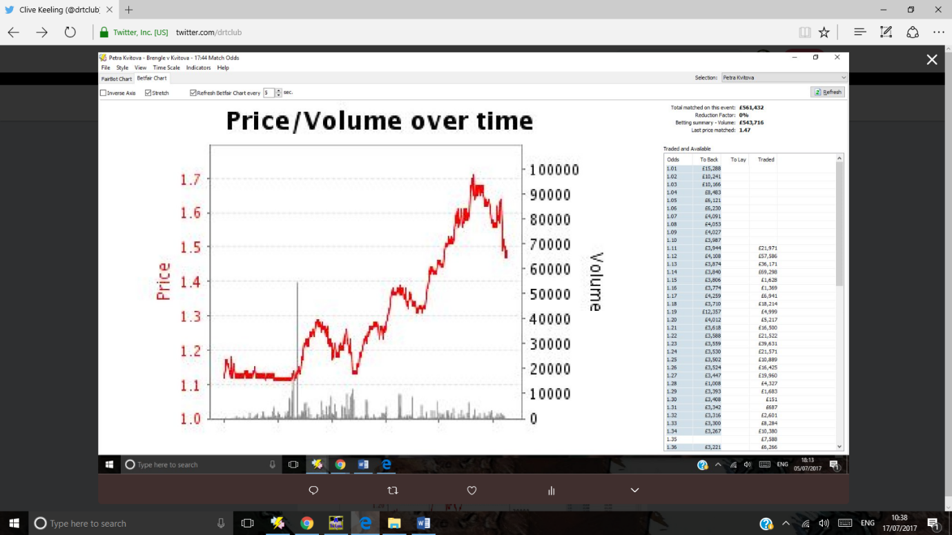
July 5th Venus Williams
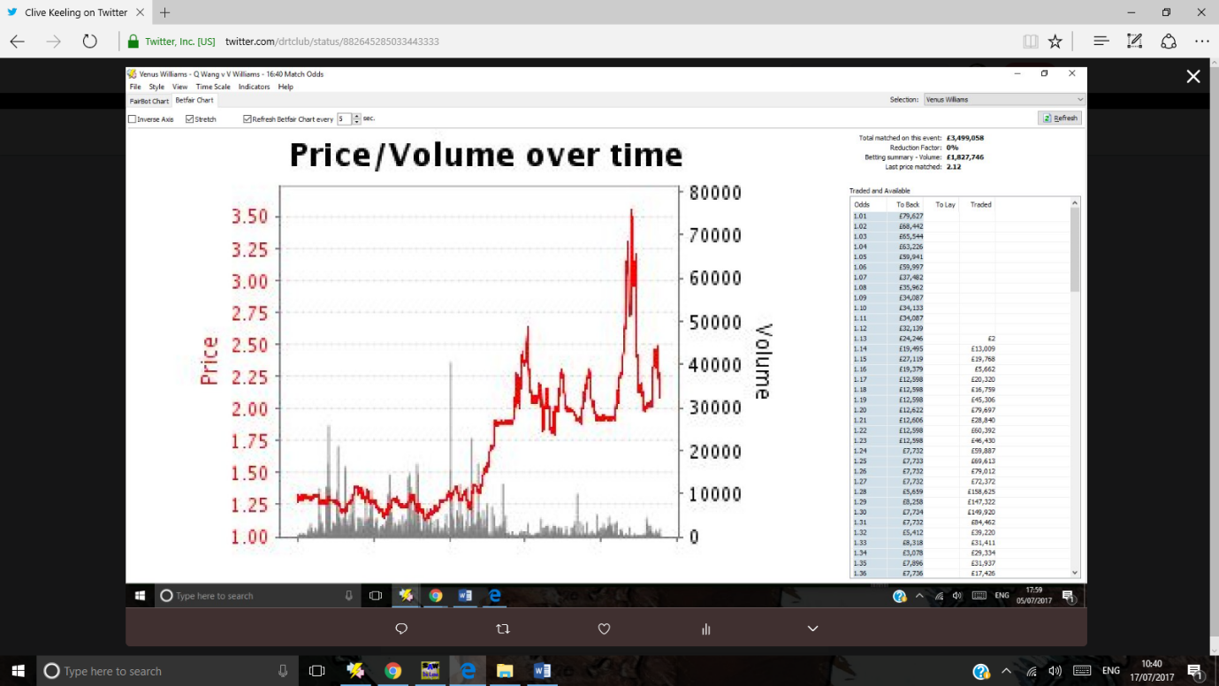
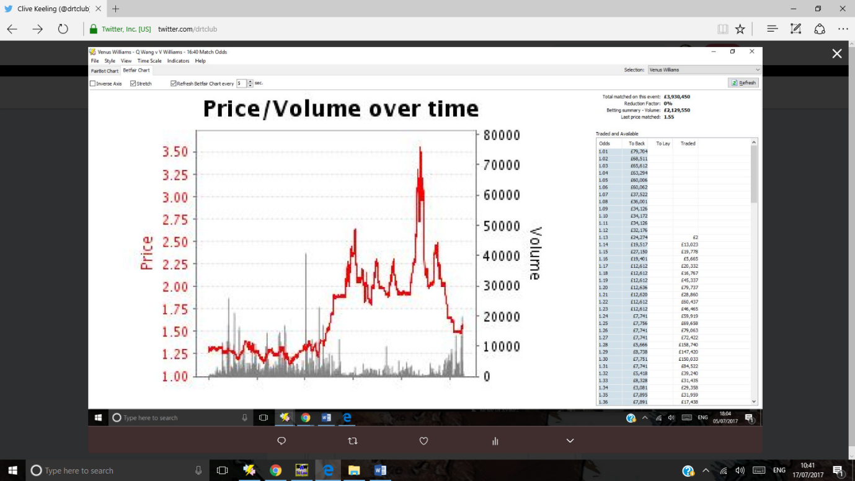
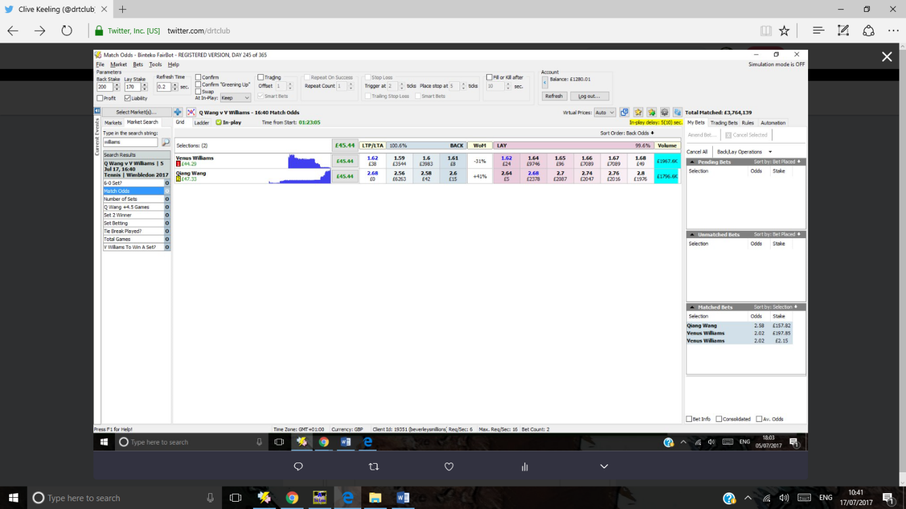
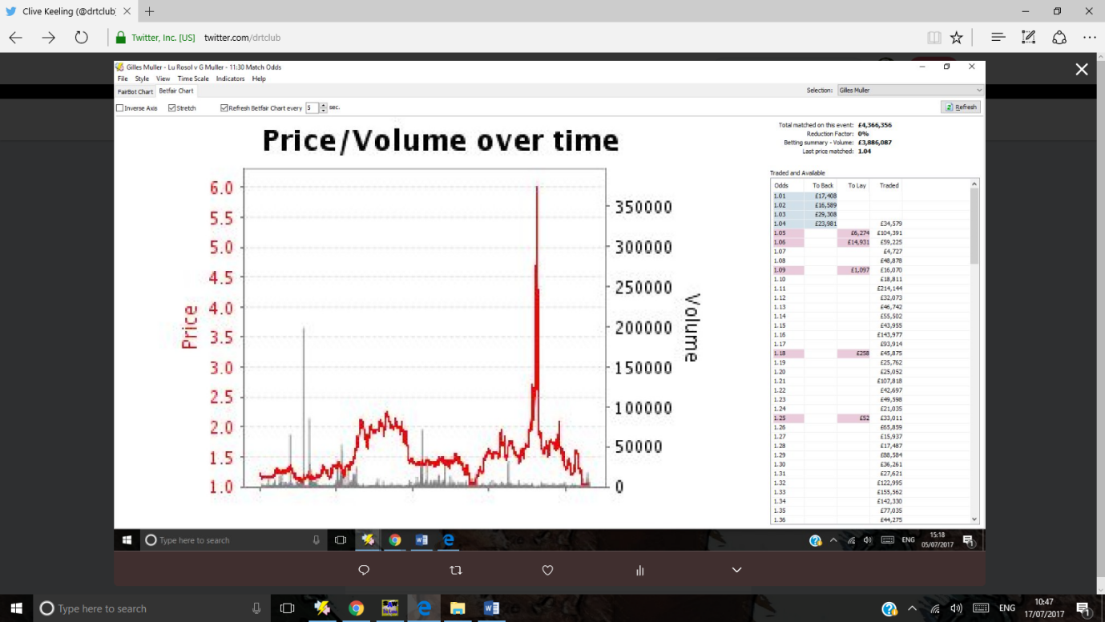
- Clive Keeling‏Protected Tweets @drtclub Jul 5
More

1.05 lay if you backed him at evens please get the feck out of there! A high of 6
Rosol leading here. But research showed Gilles Muller was superb in warm up grass court events for this Wimbledon event. Use that knowledge and lay Rosol.
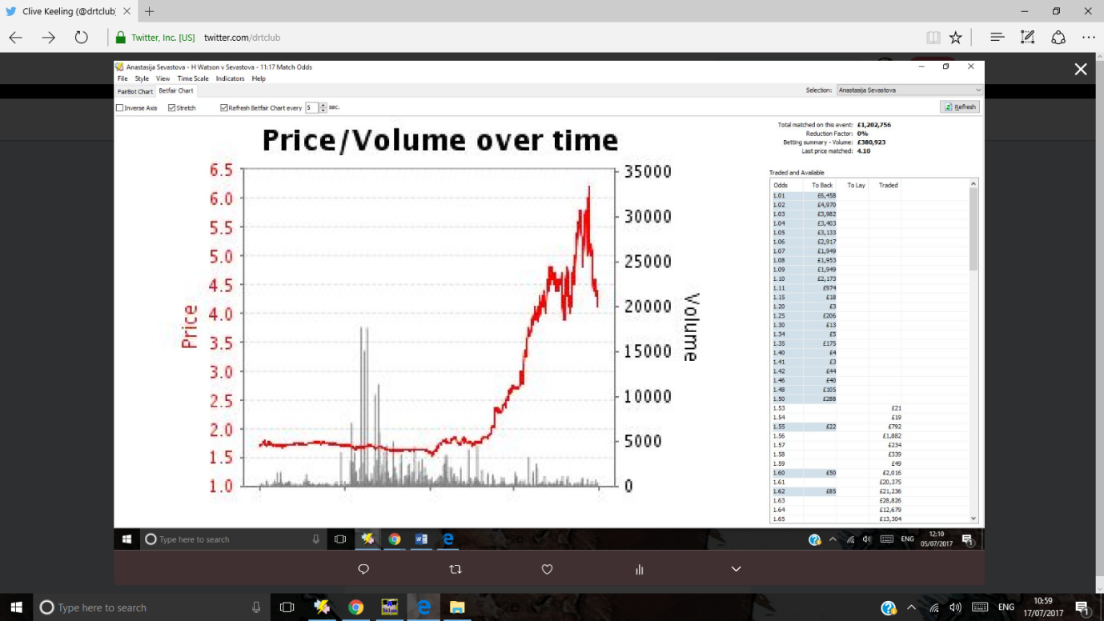
- Clive Keeling‏Protected Tweets @drtclub Jul 5
More

will we see the n graph from Sevastova? it is starting
- Clive Keeling‏Protected Tweets @drtclub Jul 5
More

there's the n shape I was looking for. And a good advert for a bit of research. 26th ranked Mallorca grass court tournament winner!!
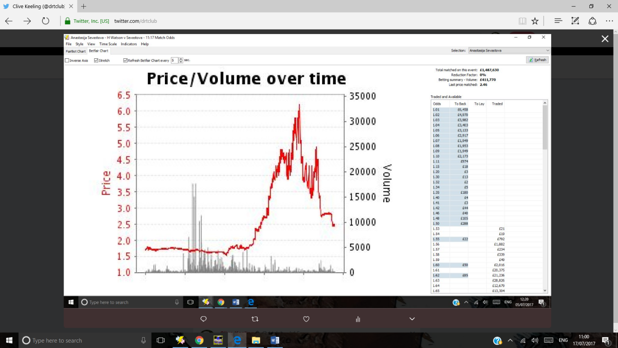

Lucic-baroni solid player despite ranking
- Clive Keeling‏Protected Tweets @drtclub Jul 3
More

3.3 tempts me in with Lucic-baroni
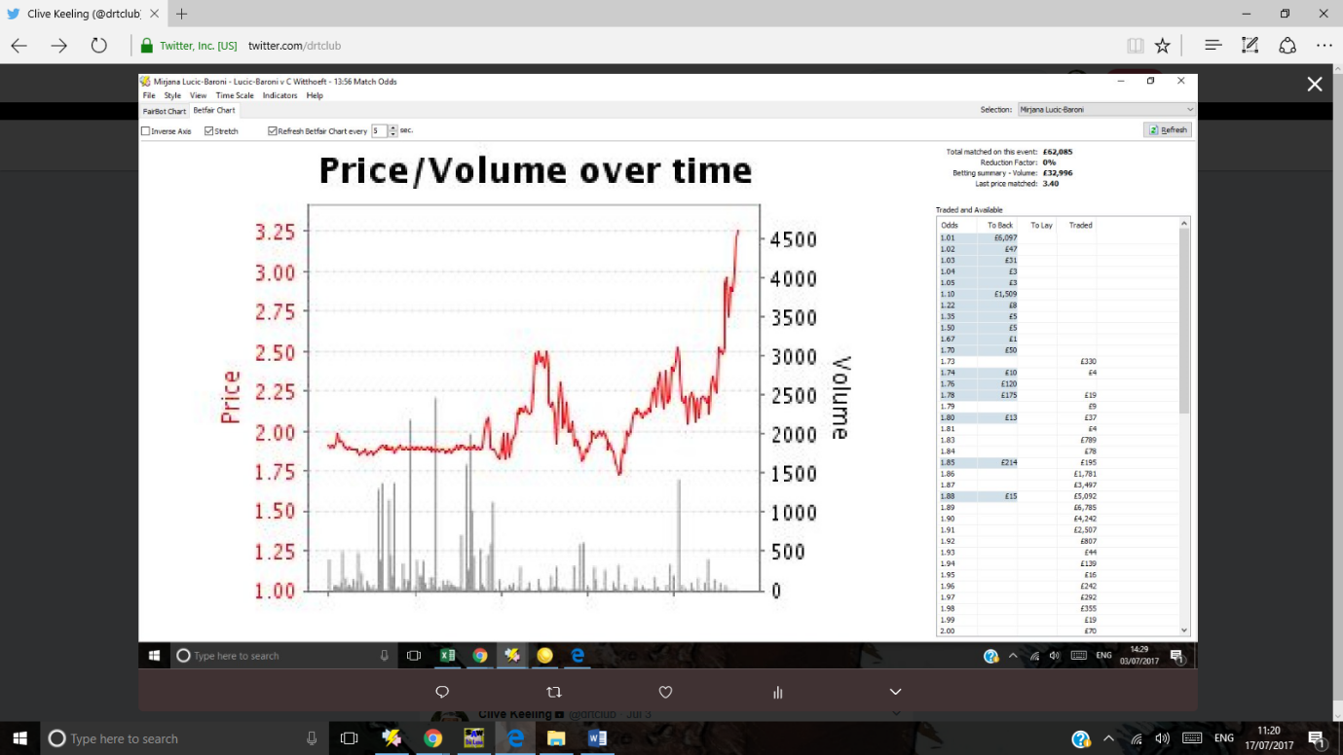
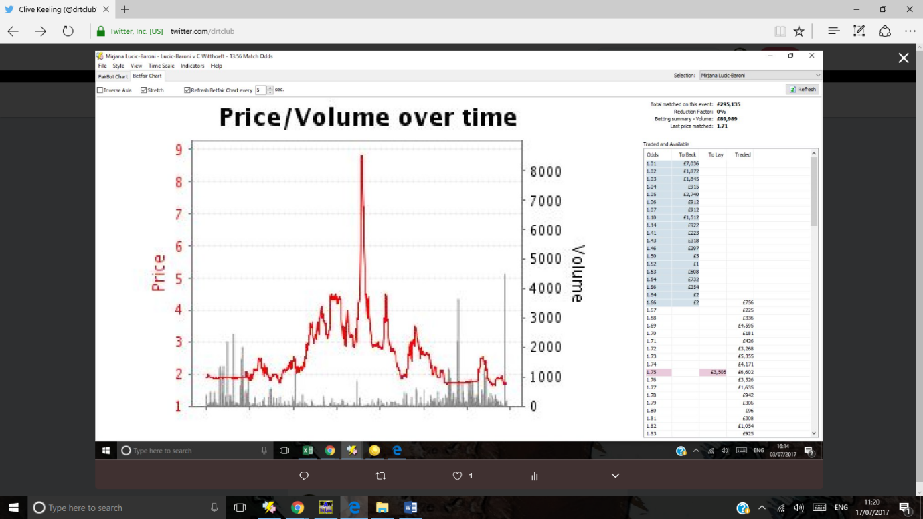

Karen khachanov
- Clive Keeling‏Protected Tweets @drtclub Jul 3
More

Karen Khachanov a player I like. Missed the high alas. Looks like he has final set sorted out.
