Earlier we discussed how the Price/Volume over time graph was a graphical representation of how a particular player was performing during a match.
Charts show patterns. Learn to read these patterns and you can get a good idea what may happen in the future, and where you can enter and exit trades. Let me take you through a few chart patterns as they pertain to tennis. Those of you who have dabbled in the financial markets will recognise a few of the terms mentioned.

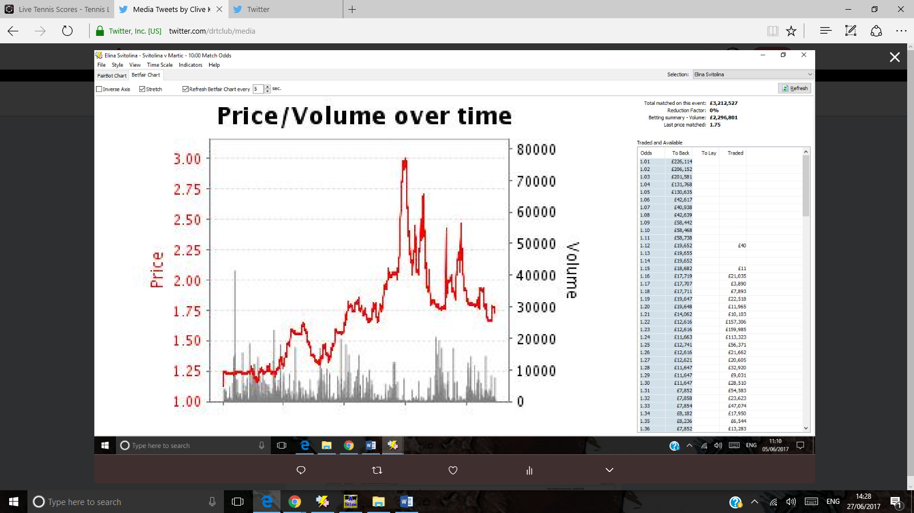
In financial trading we look at the graph of a share and see the story behind the share. In tennis we look at the graph of a player and see their story.
This is the graph for Elina Svitolina. We see she was a 1.25 favourite pre-match. Very strong favourite. But she sees early struggles. The key chart pattern I want to show you is called
‘ lower highs and lower lows’
A high of 3 for a 1.25 shot is the first point to note. The first V signals the potential for lower highs and lower lows.
Resistance. In charts you often see the odds try out an important price level.

Here we have resistance at 1.75 and then a down trend to the right of the graph
Svitolina v martic june 5

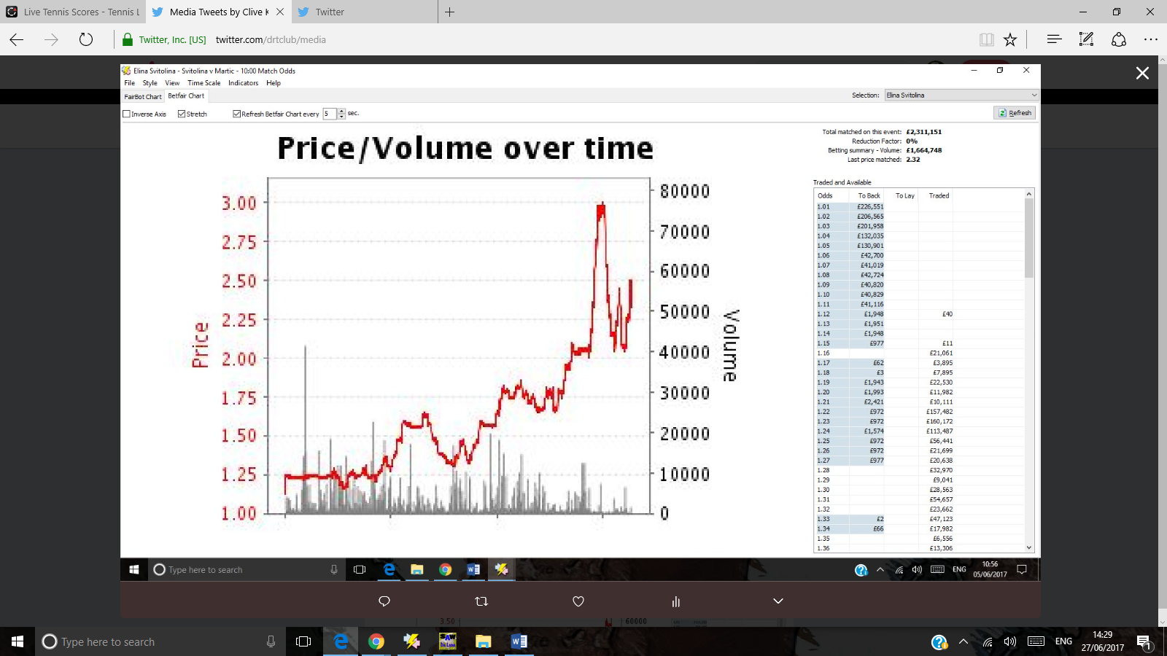
There are 2 areas of resistance here. 1.75 odds initially. Then 2.00 which switches to an area of support, from which the odds bounce upwards.

High of 3 very backable.
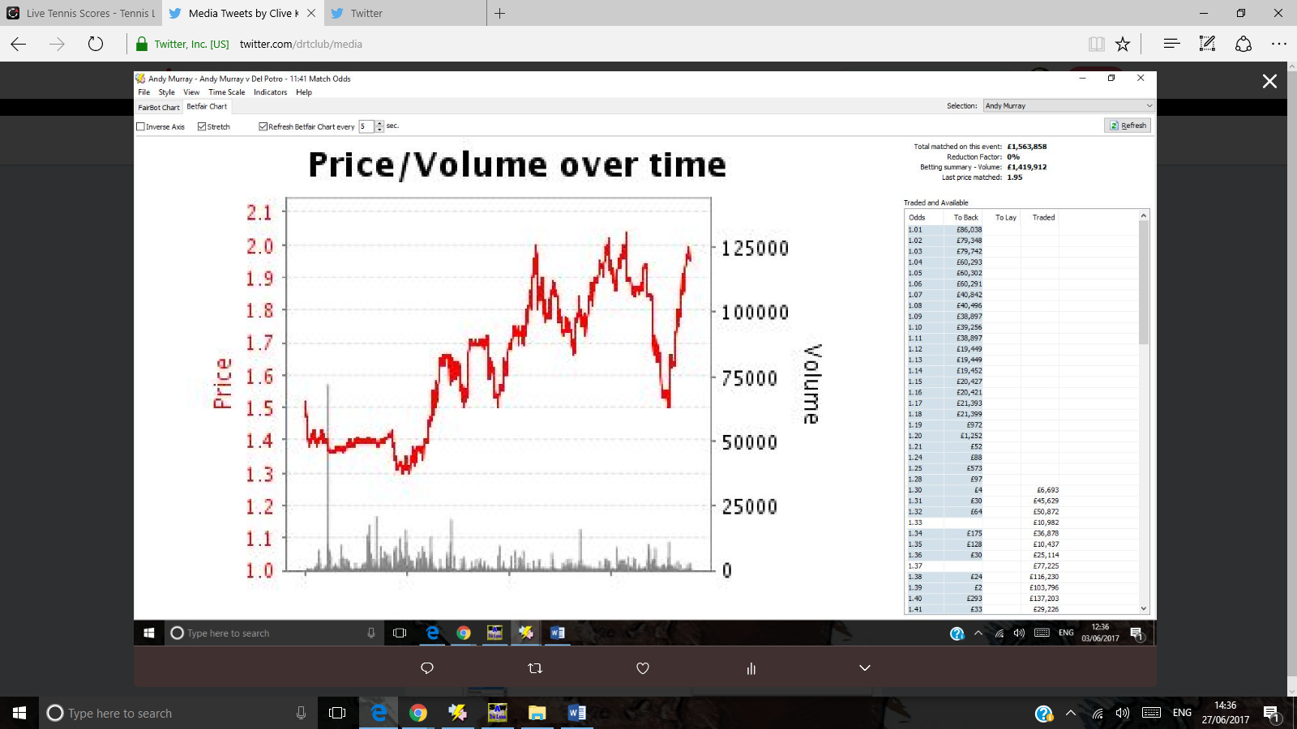
Andy Murray plays Del Potro. The market won’t allow Andy’s odds to drop below 1.3. Lay him if he hits 1.3 therefore. The next level of support is 1.5 which is a consistent level. Lay Andy if his odds hit 1.5 as they did after the initial 3 tests.
2.00 was the next area of resistance. Andy’s odds were not allowed to move over 2.00. back him when he hits 2.00 or higher as he tends to trade shorter.
Andy Murray’s graph v Del Potro
June 3rd
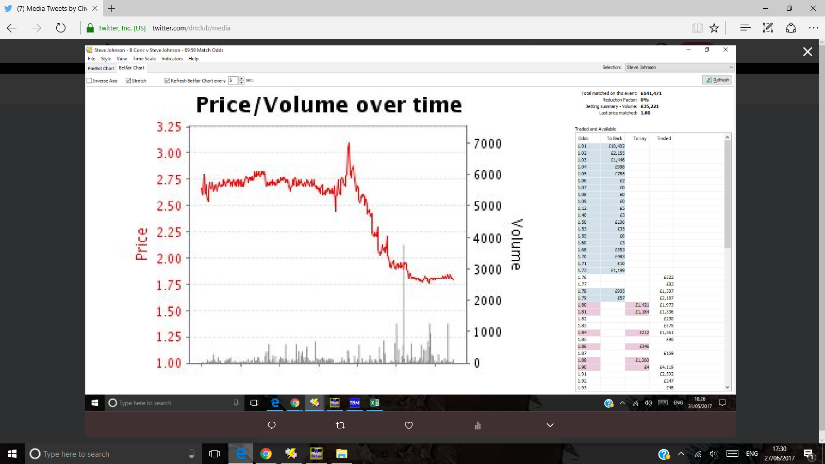
If this area of support continues, 1.75 will be the key odds with which to lay Steve Johnson? 3 could be the odds at which to back him?
Coric v Johnson. Resistance at 1.75 as Steve Johnson dominates early on
May 31st
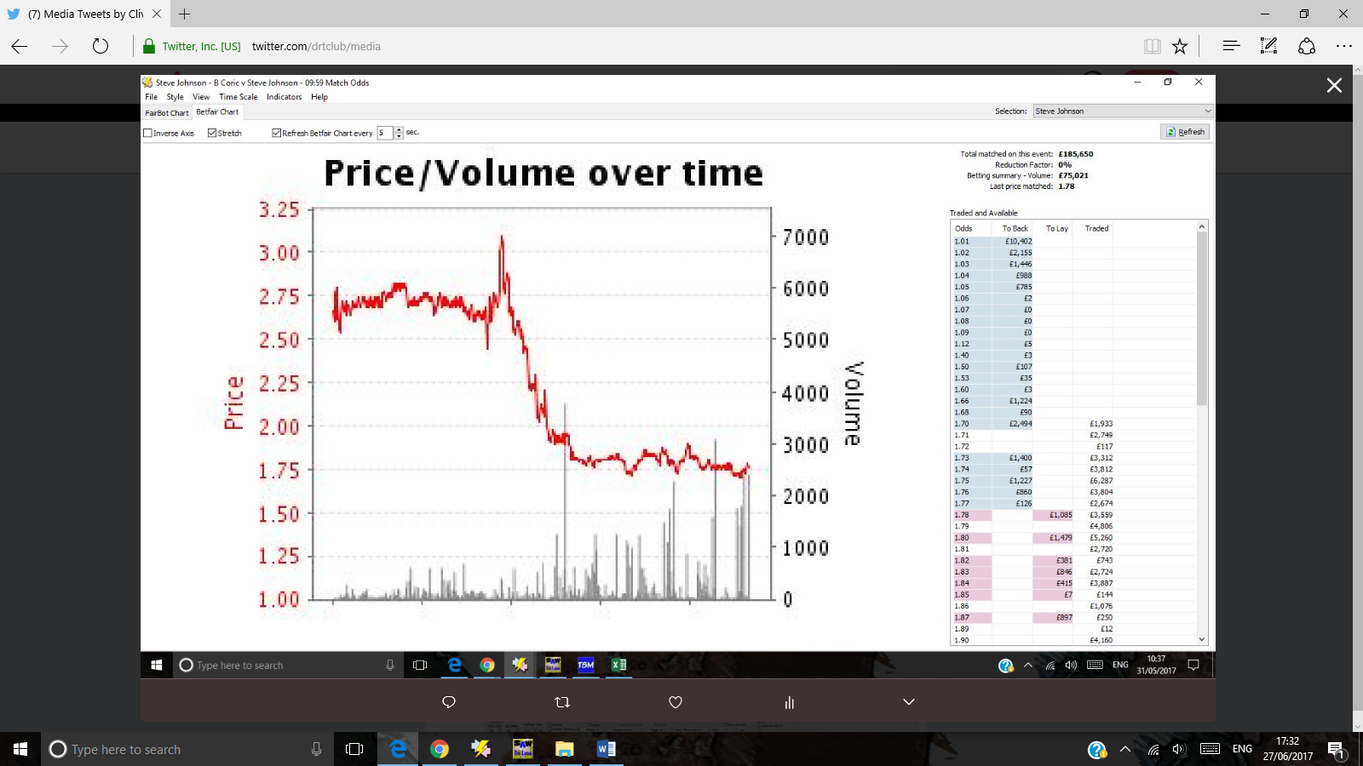
Do you think it would be significant if Johnson’s odds were to drop below 1.75
And still the support at 1.75 continues.

Resistance continues at 1.75 odds.
How would you play this?
NEGATIVE? Market not taken by Steve Johnson’s good start and thinks this match is far from over.

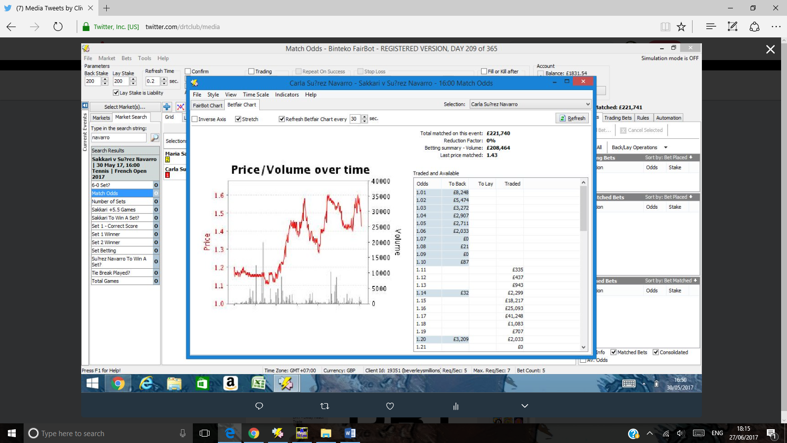
Resistance at 1.6 for Navarro – may 30th
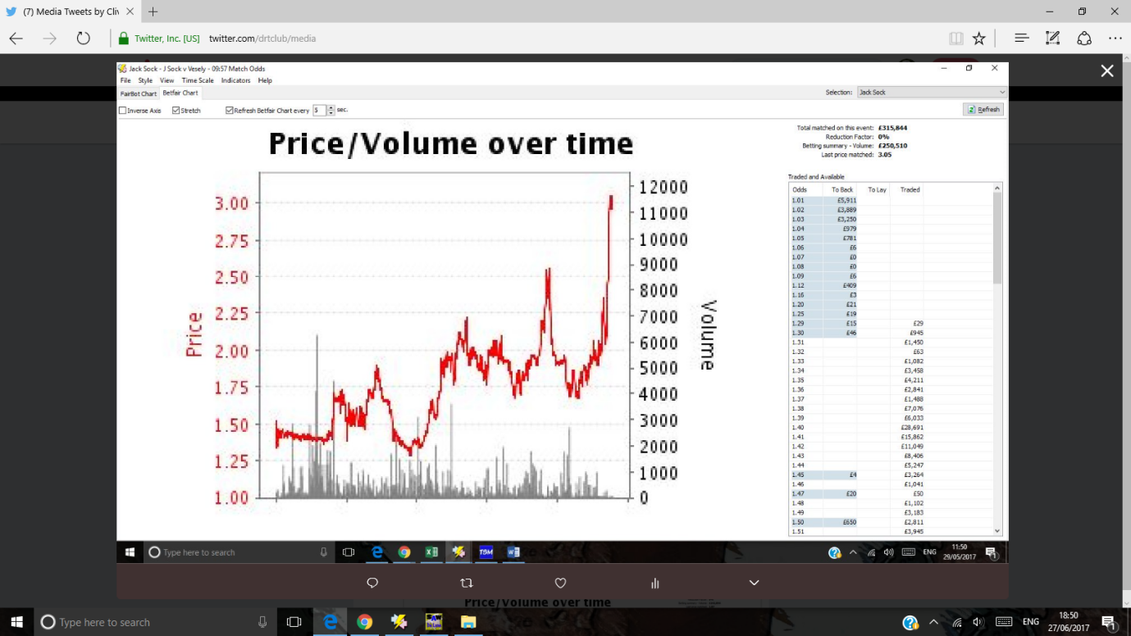
A series of higher highs for Sock v Vesely may 29th
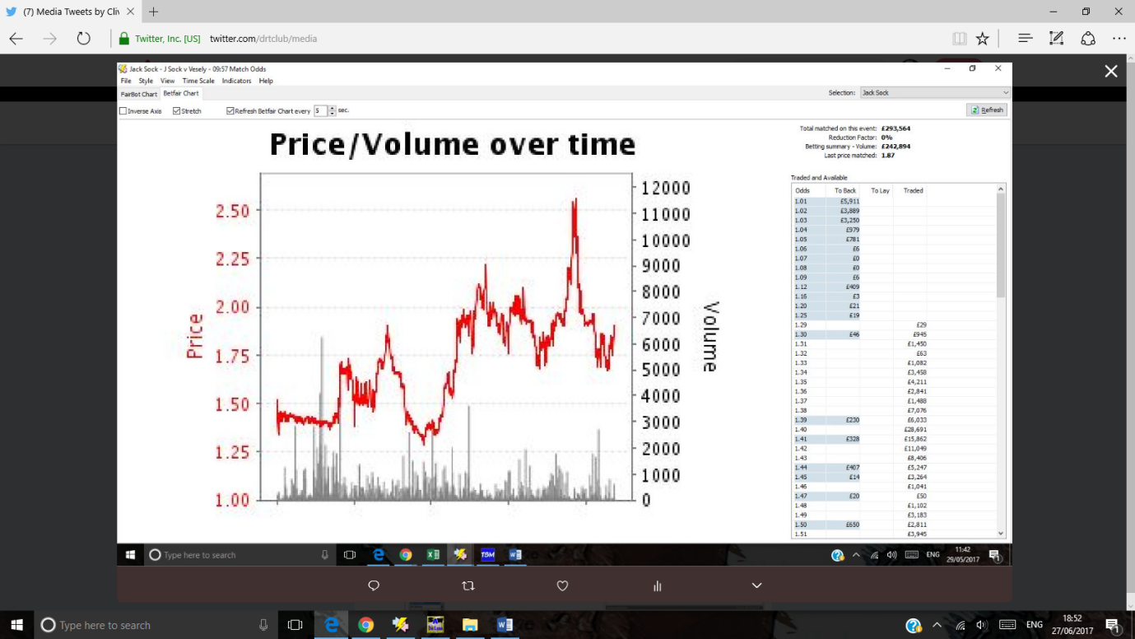
Same match 1.75 is a support and resistance line
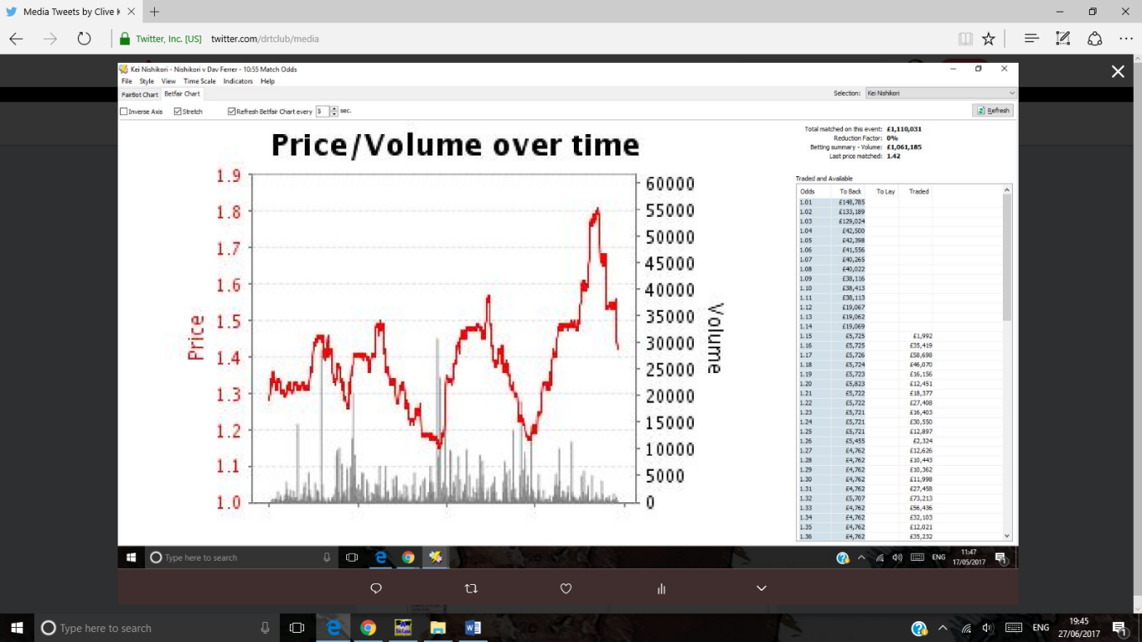
- Clive Keeling‏Protected Tweets @drtclub May 17
More

Missed the 1.8 about Nishikori. He was 1.65 earlier . Missed that too!

- Clive Keeling‏Protected Tweets @drtclub Jul 8
More

the breakthrough for Monfils down to 1.48
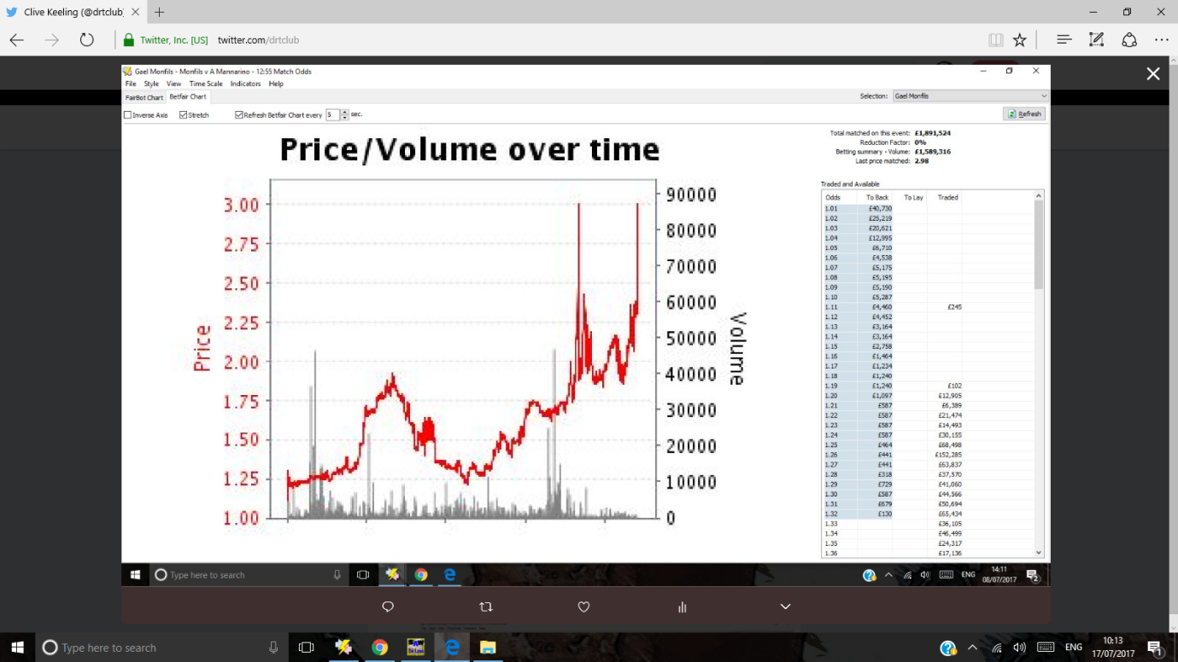
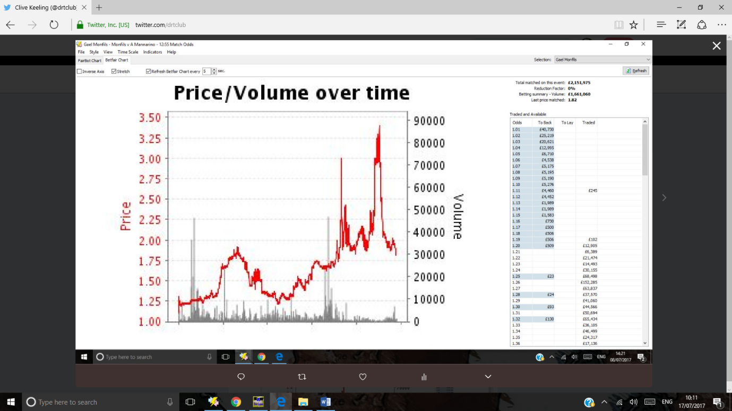

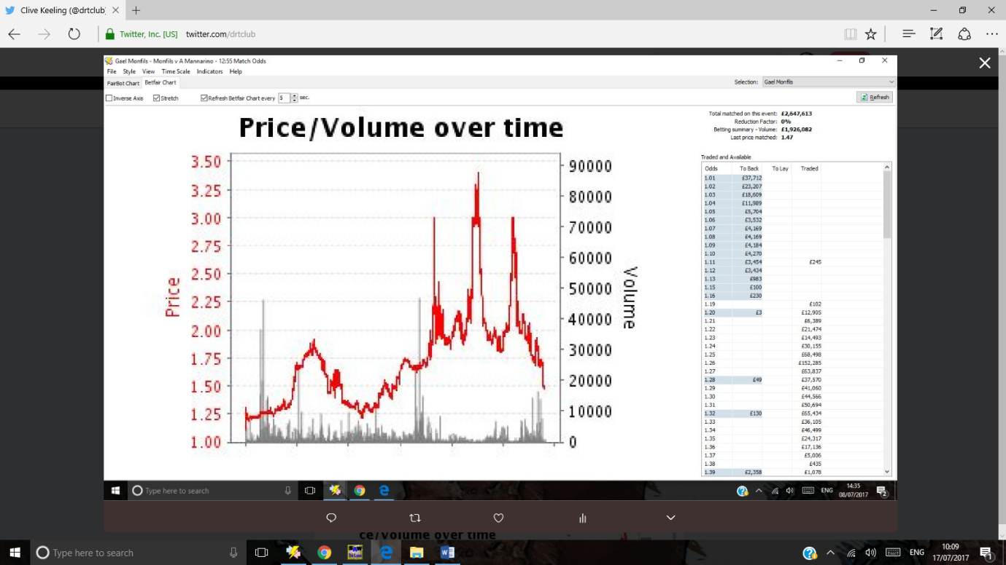
Gael Monfils – the market tested 3.00 odds twice , went through it to 3.25 but thought better of it. Market unwilling to let Gael’s odds rise higher – suggestion he is on the cusp f a breakthrough. Look at the busy support at 1.75. Break through 1.75 and that is the key to the match.

- Clive Keeling‏Protected Tweets @drtclub Jul 4
More

Youzhny layable at 1.29 - look at the bounce off 1.25 previously and look at his pre match odds
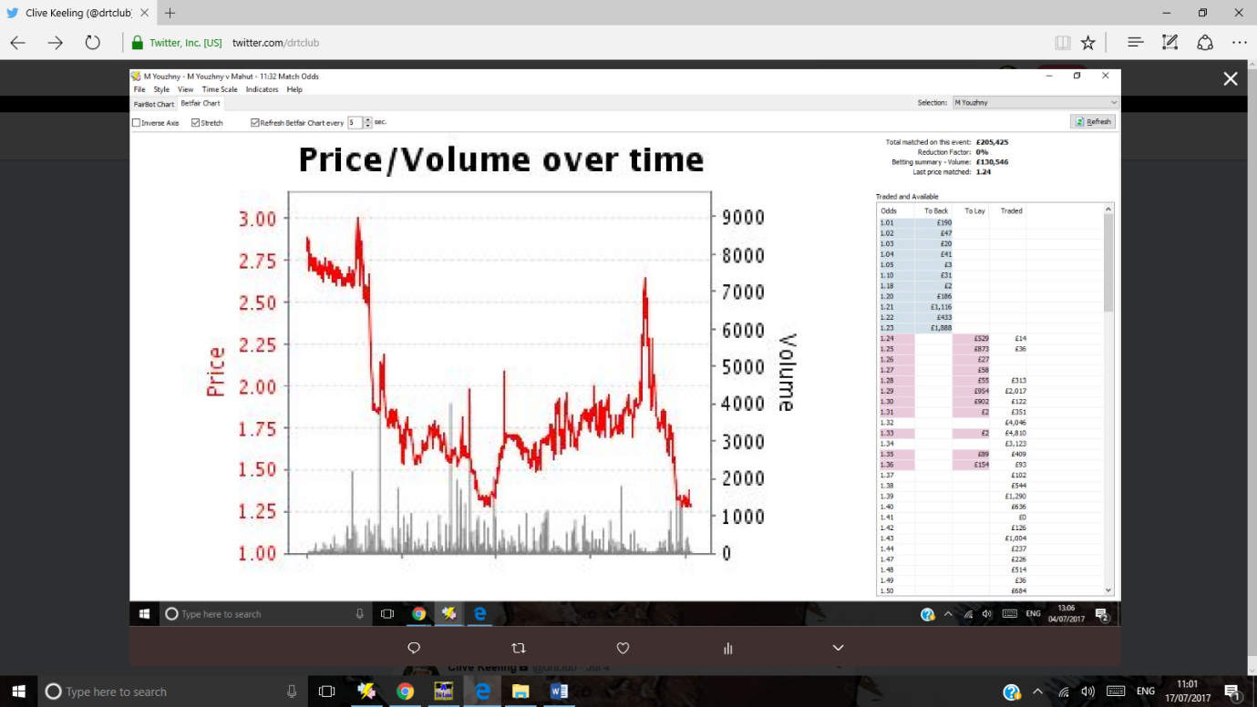

- Clive Keeling‏Protected Tweets @drtclub Jul 4
More

Escobedo - lay him if his odds get to 1.2 again. Look at the resistance at 1.2 and the swing up to 1.8!!
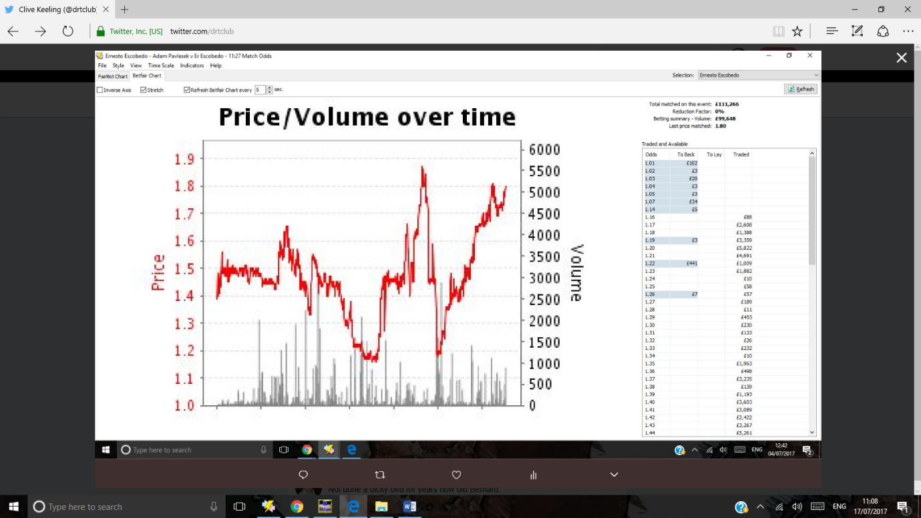

- Clive Keeling‏Protected Tweets @drtclub Jul 3
More

series of lower lows for Kevin Anderson a good sign as I backed him 2.65 earlier.
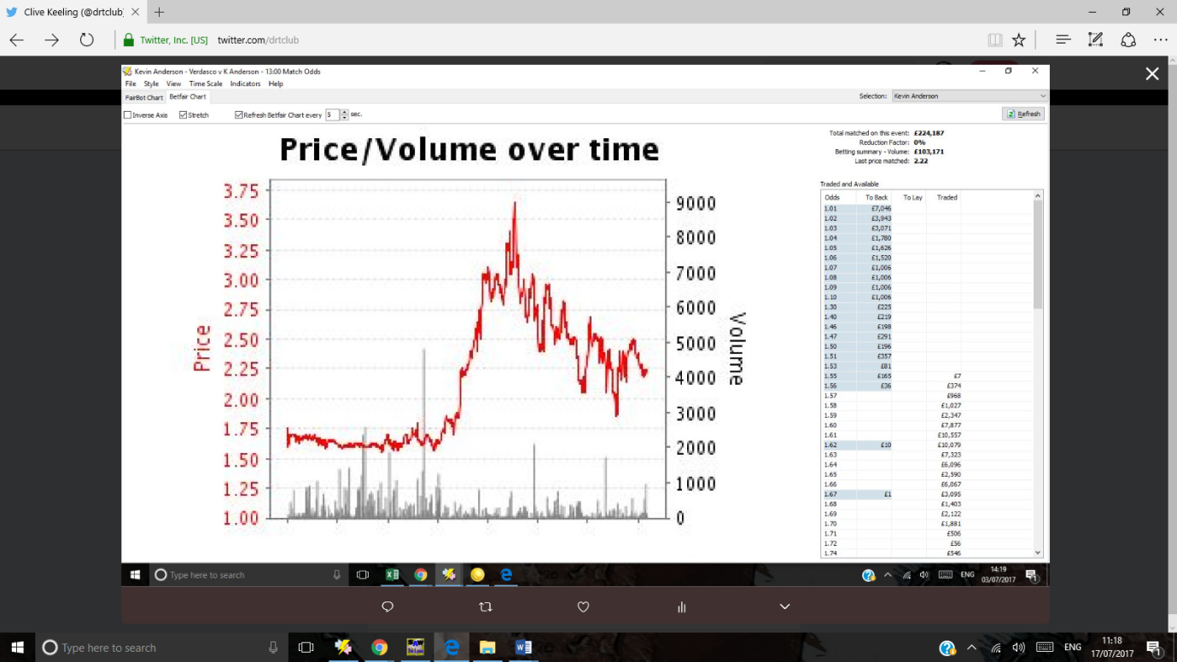
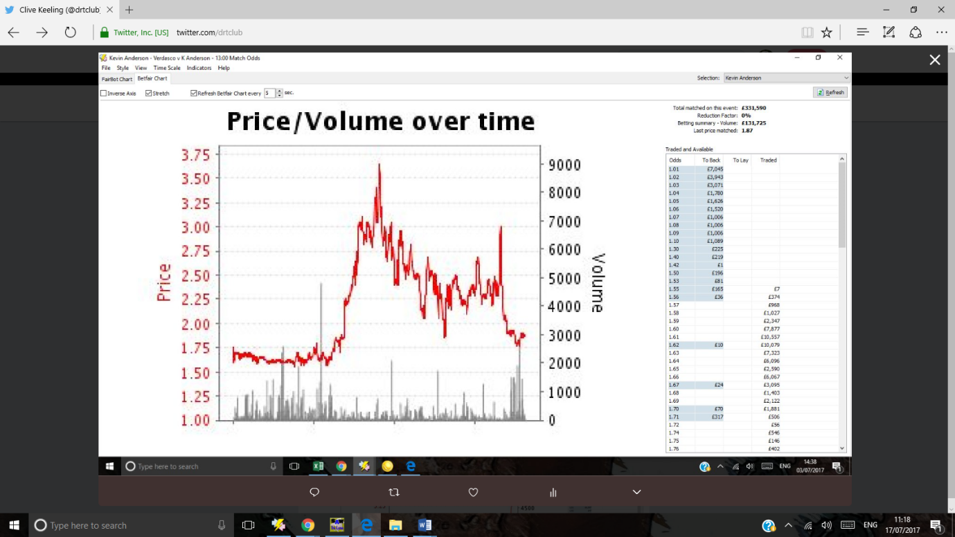
Anderson 2nd set winner after losing first set
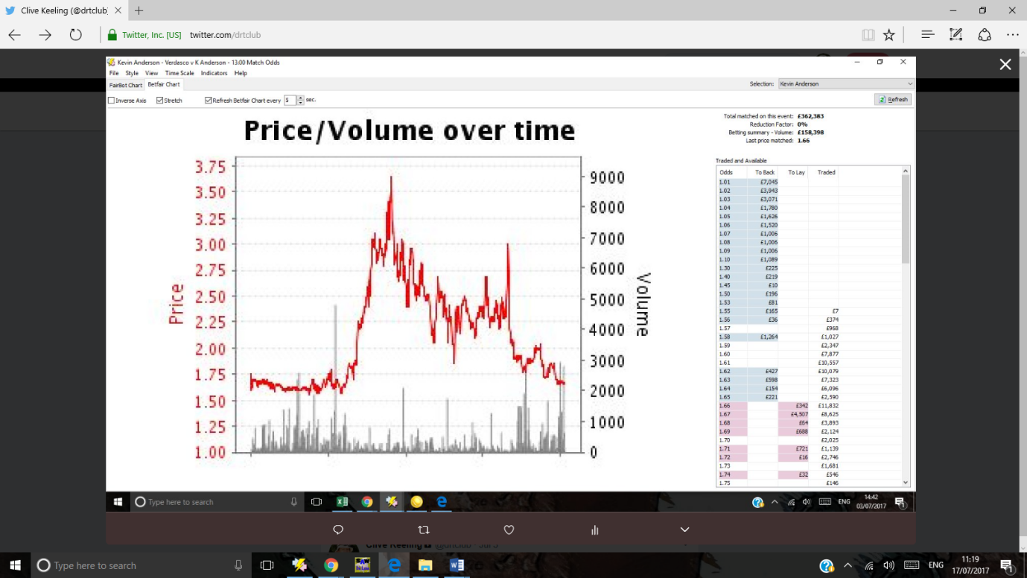

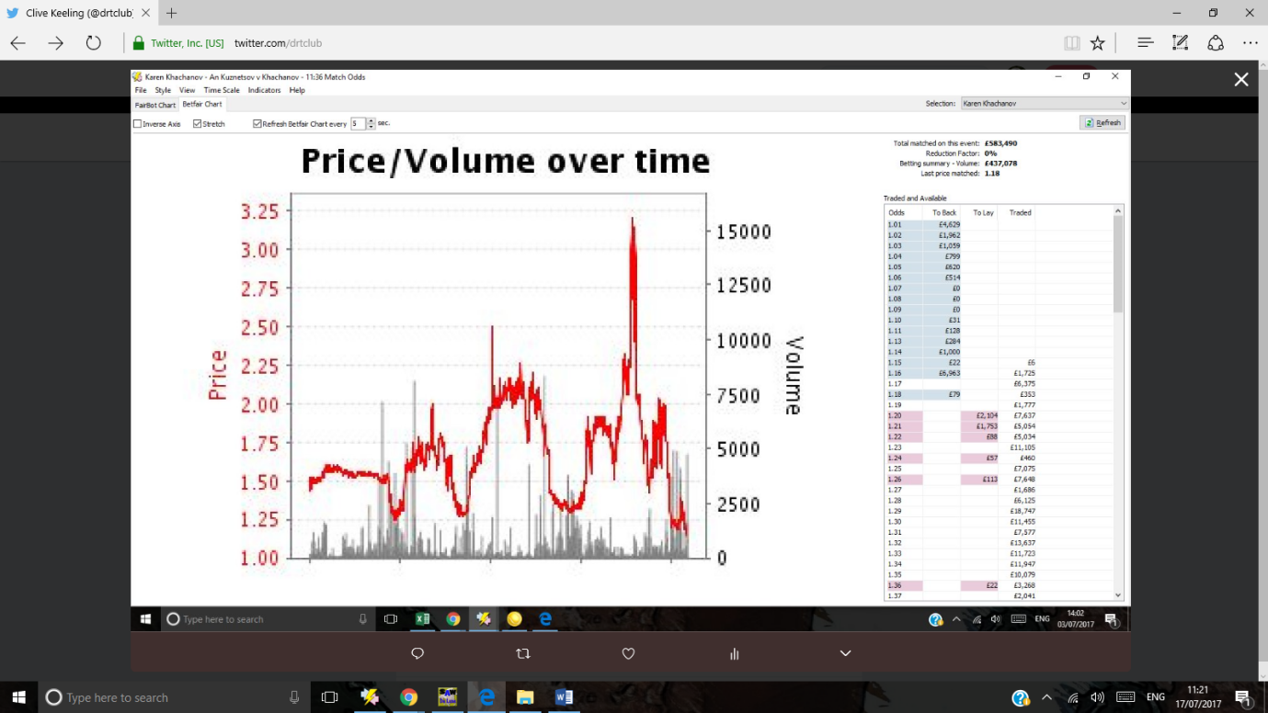
3 higher highs and after each high, a drop to around 1.25

