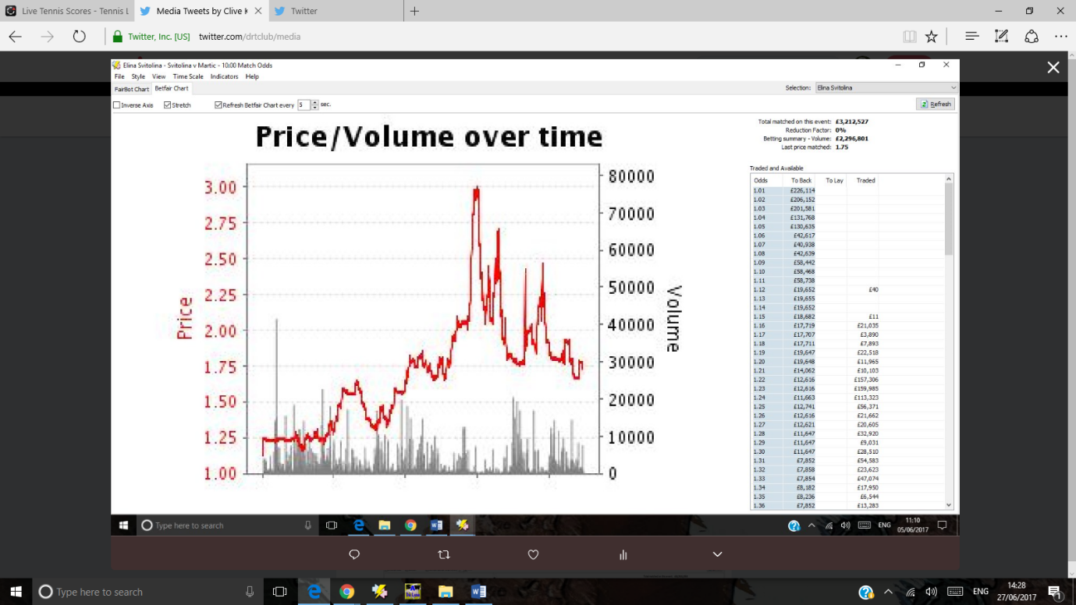

Reading a price/volume graph

These graphs are a visual representation of how a match unfolds.

Here we have resistance at 1.75 and then a down trend to the right of the graph

Svitolina v martic june 5

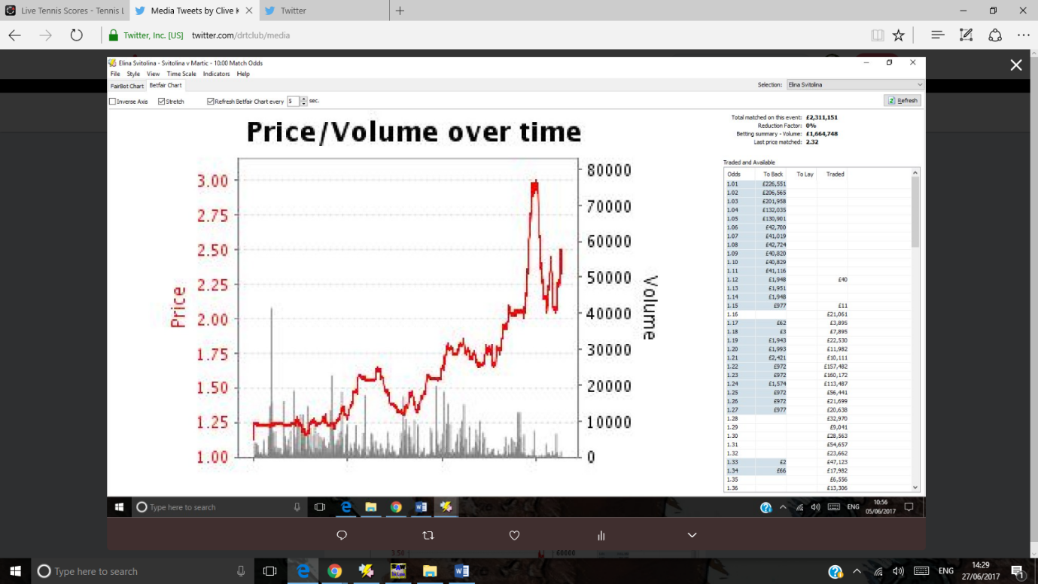

High of 3 very backable.

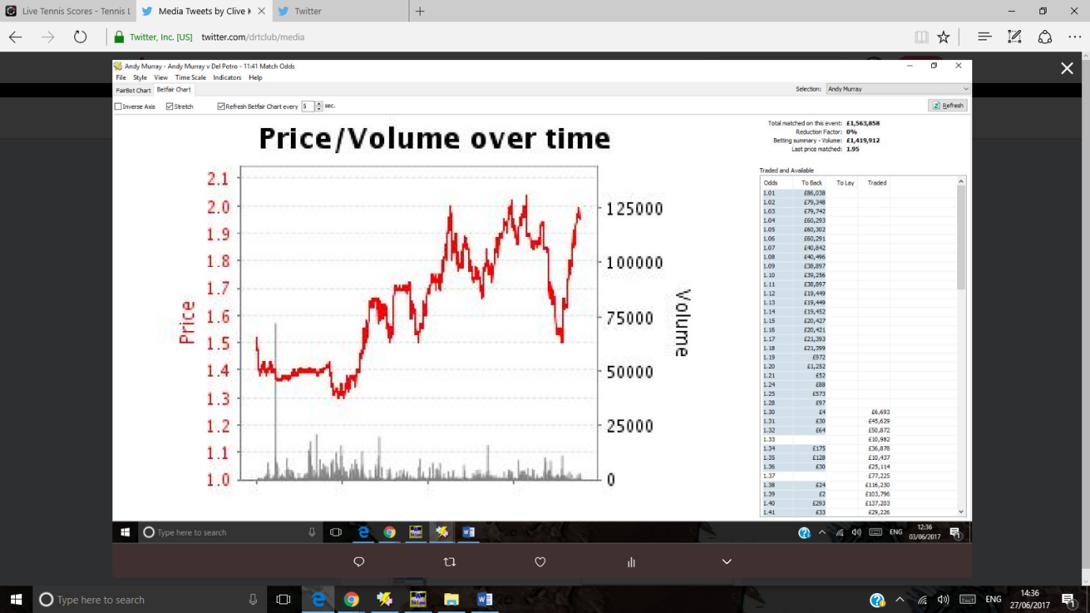

Look at the resistance line at 1.5. It won’t be broken. And the line at evens.

Andy Murray’s graph v Del Potro

June 3rd

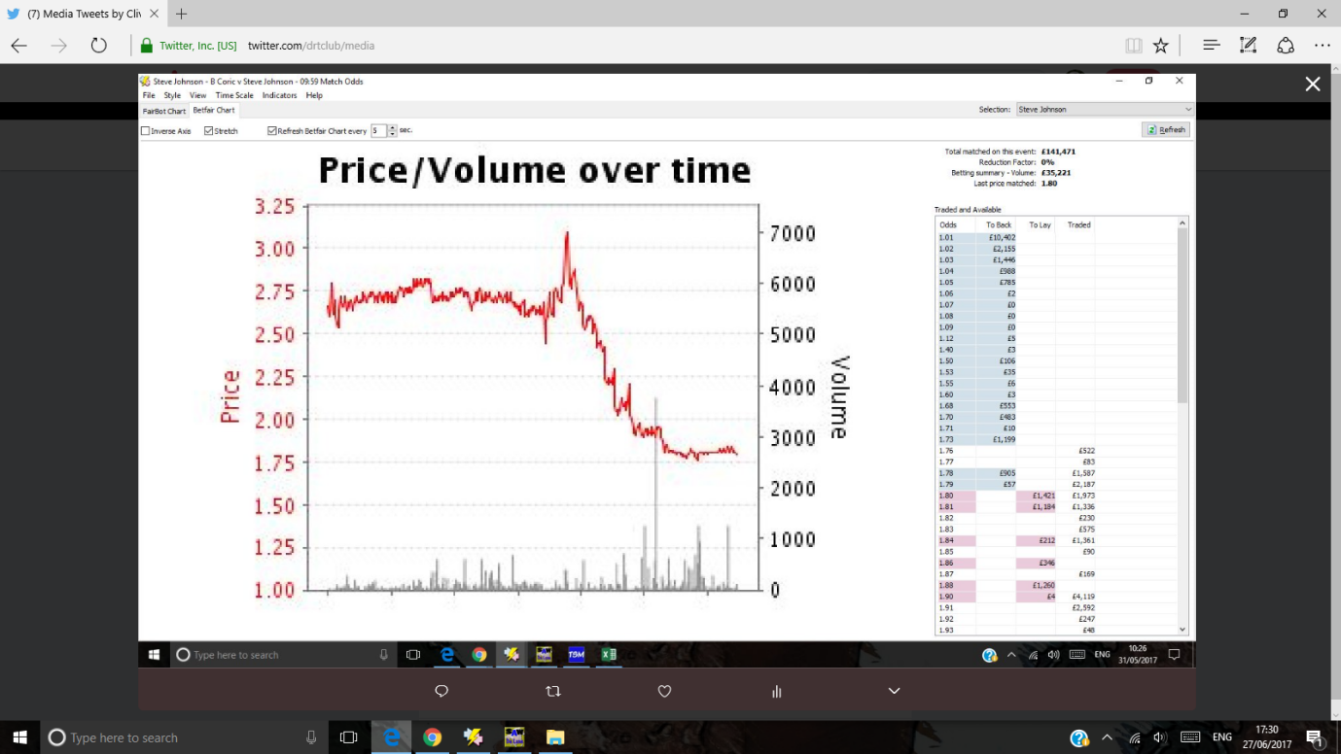

Coric v Johnson. Resistance at 1.75 as Steve Johnson dominates early on

May 31st

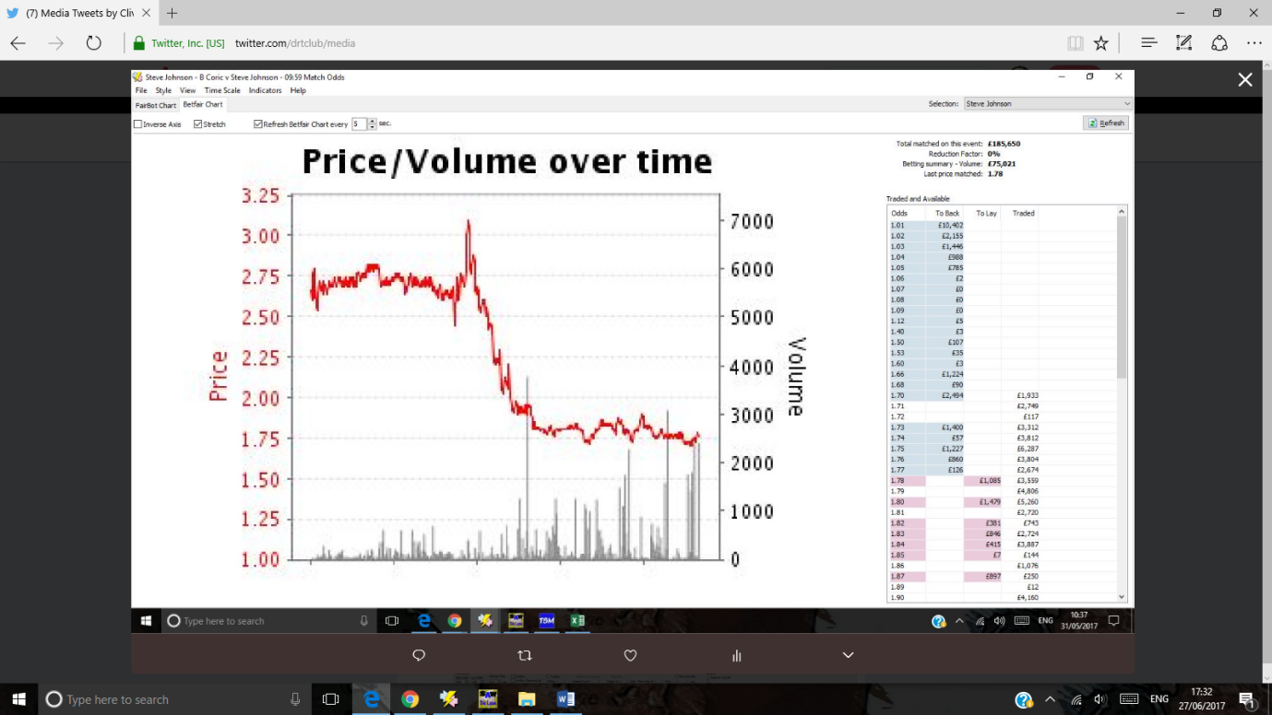

Resistance continues at 1.75 odds.

How would you play this?

NEGATIVE? Market not taken by Steve Johnson’s good start and thinks this match is far from over.

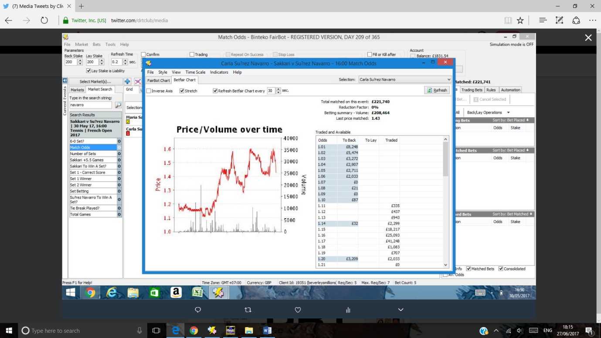

Resistance at 1.6 for Navarro – may 30th

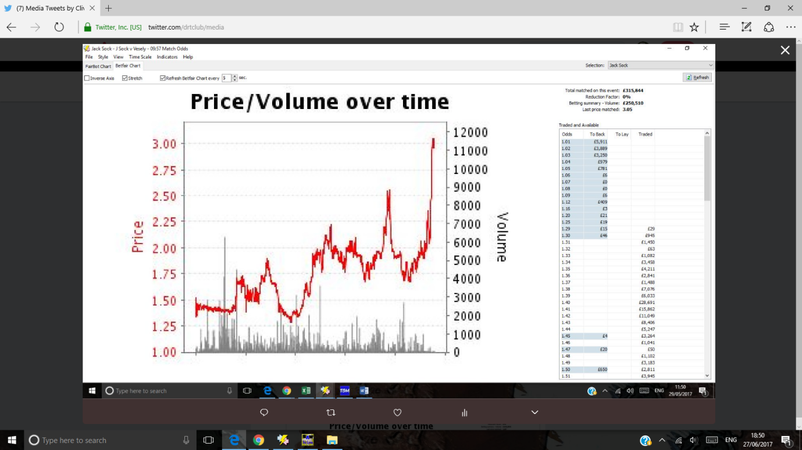

A series of higher highs for Sock v Vesely may 29th

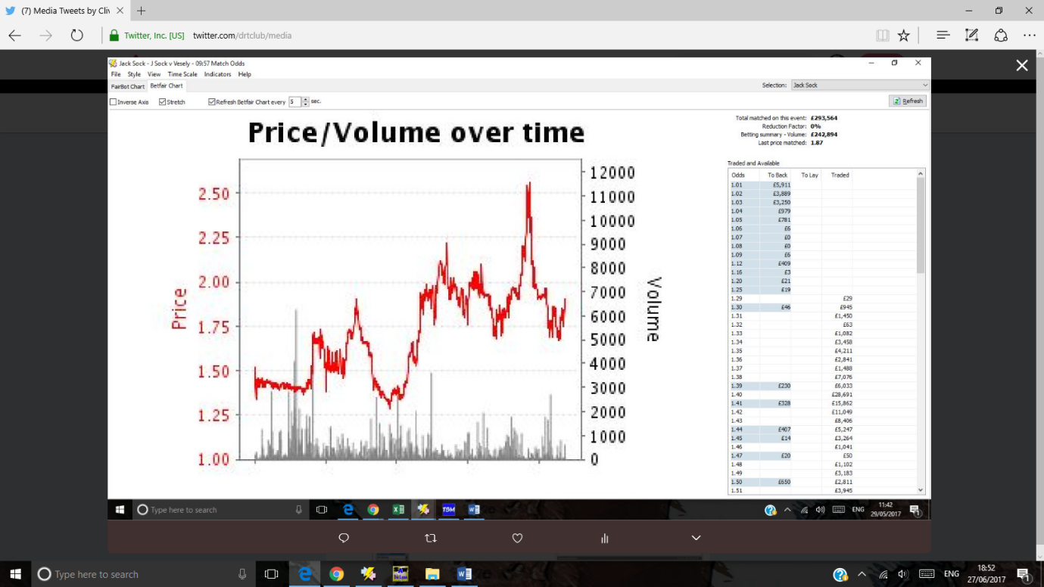

Same match 1.75 is a support and resistance line

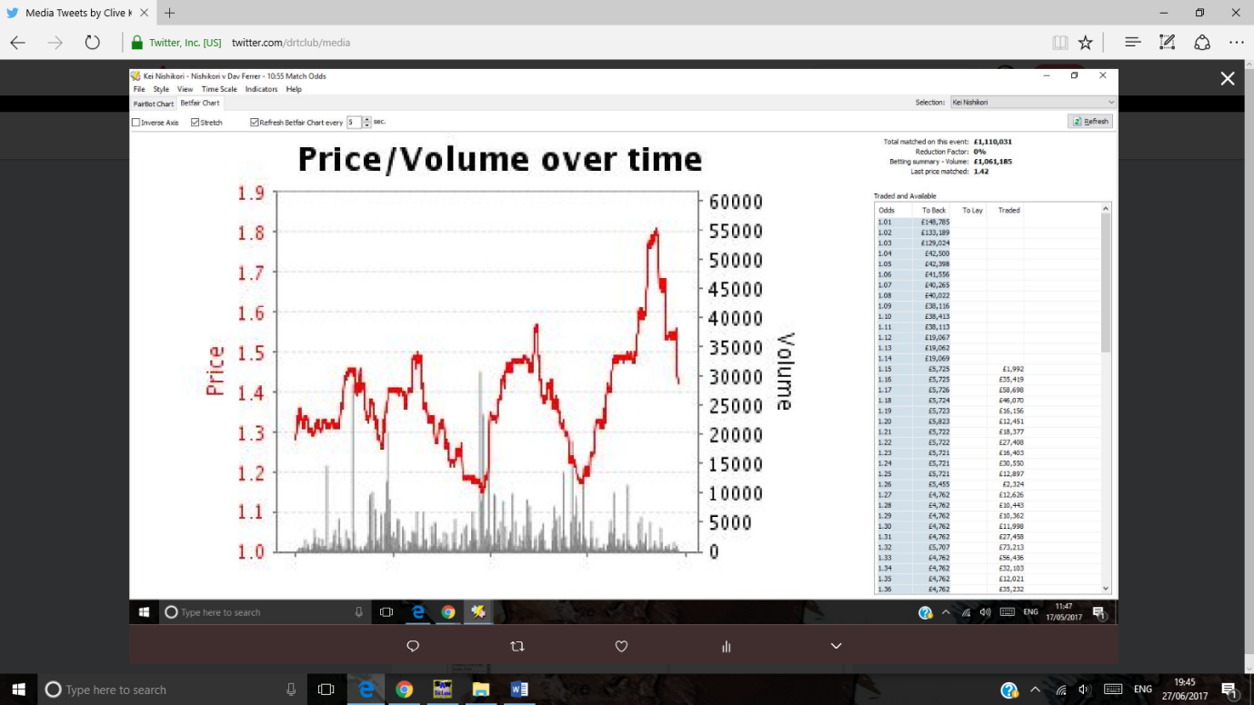

1. **[Clive Keeling](https://twitter.com/drtclub)**[‏Protected Tweets @drtclub](https://twitter.com/drtclub) [May 17](https://twitter.com/drtclub/status/864794577974075392" \o "3:47 AM - 17 May 2017)

More

* + Share via Direct Message
  + Pin to your profile page
  + Unpin from profile page
  + Delete Tweet

Missed the 1.8 about Nishikori. He was 1.65 earlier . Missed that too!