When 2-0 becomes 2-1

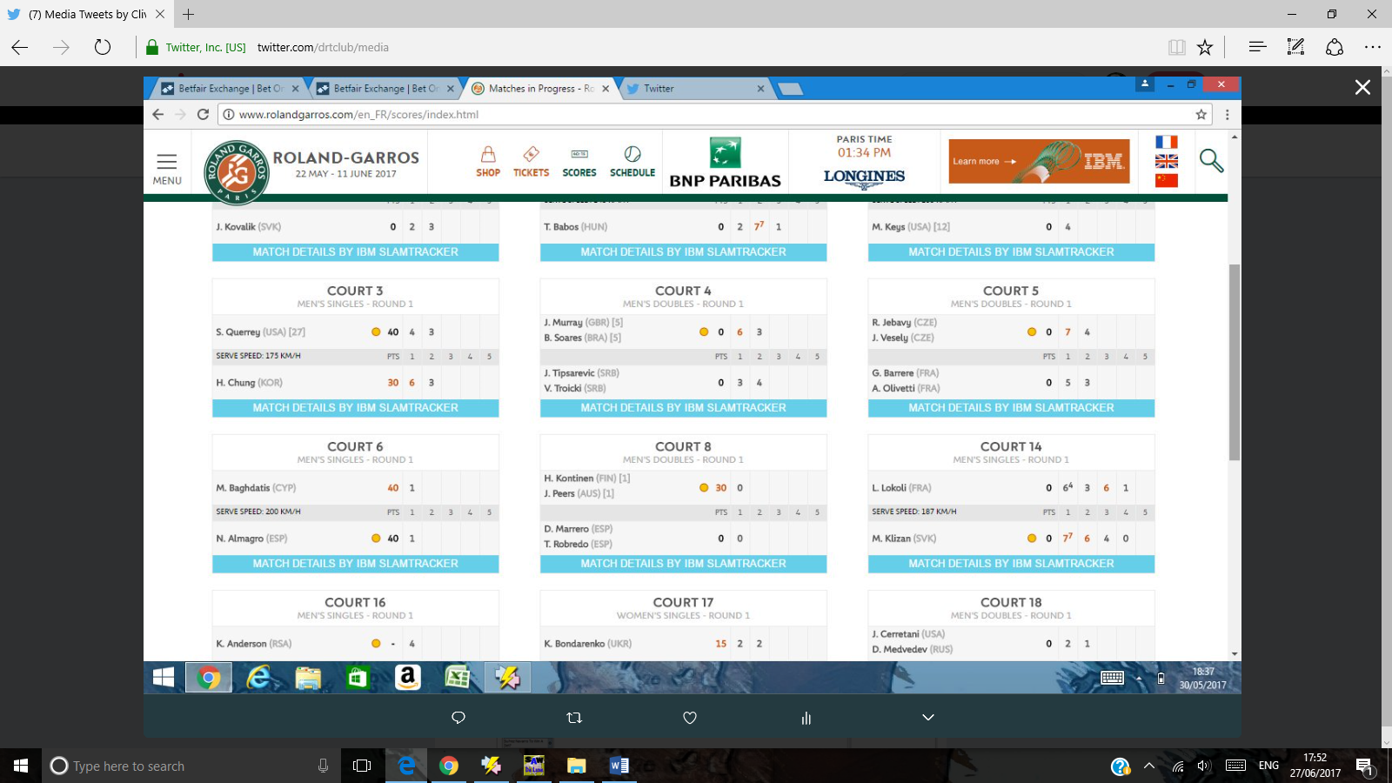

This is a phenomenon which occurs regularly in Grand Slam men’s tennis, when a player 2-0 up ( Klizan) loses the 3rd set.

Watch out for it at Australia, French, Wimbledon, US Open.

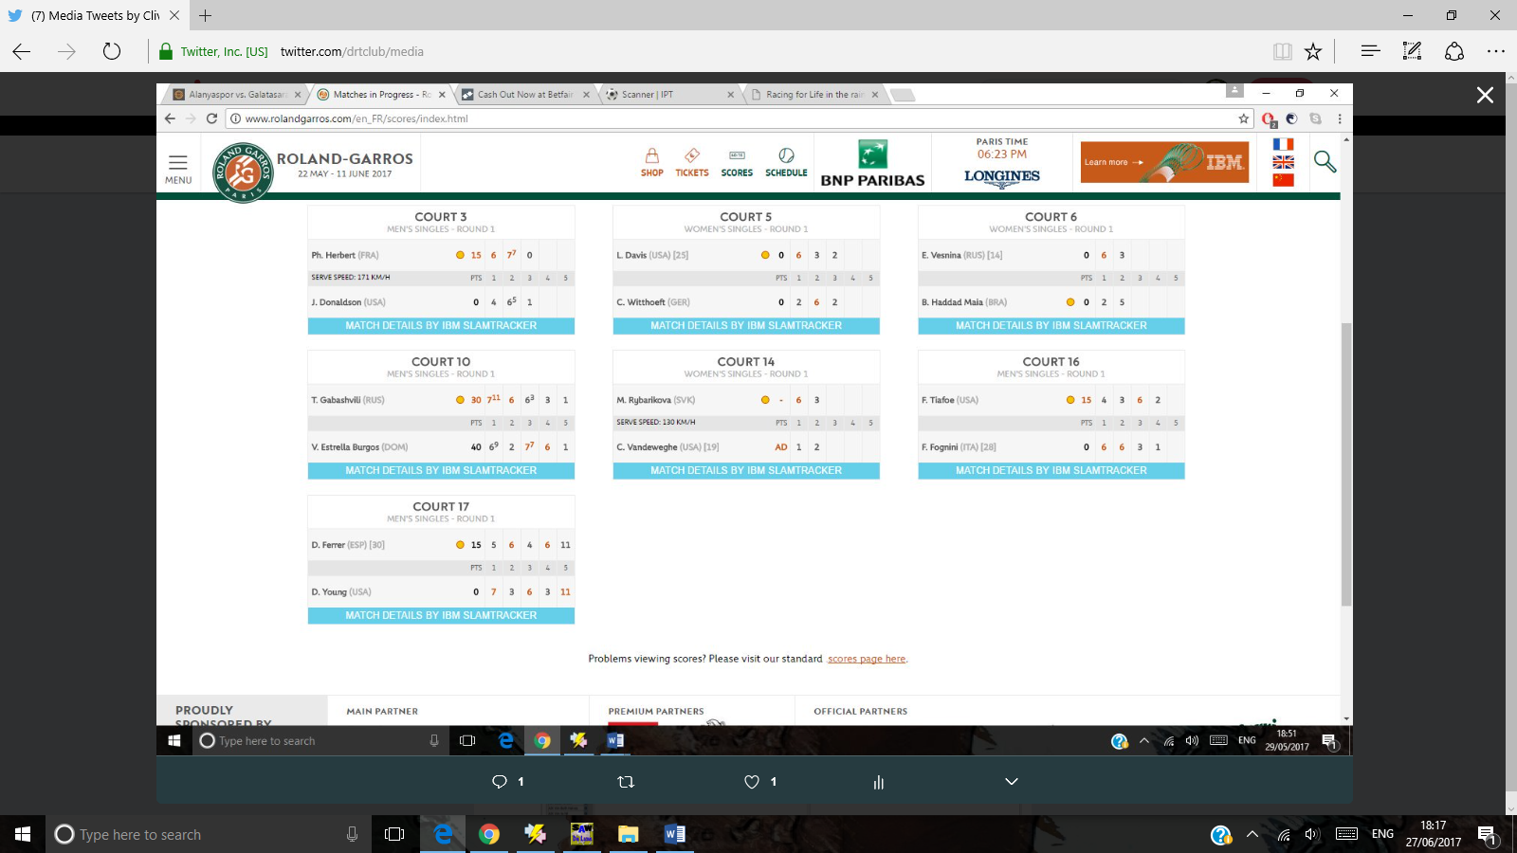

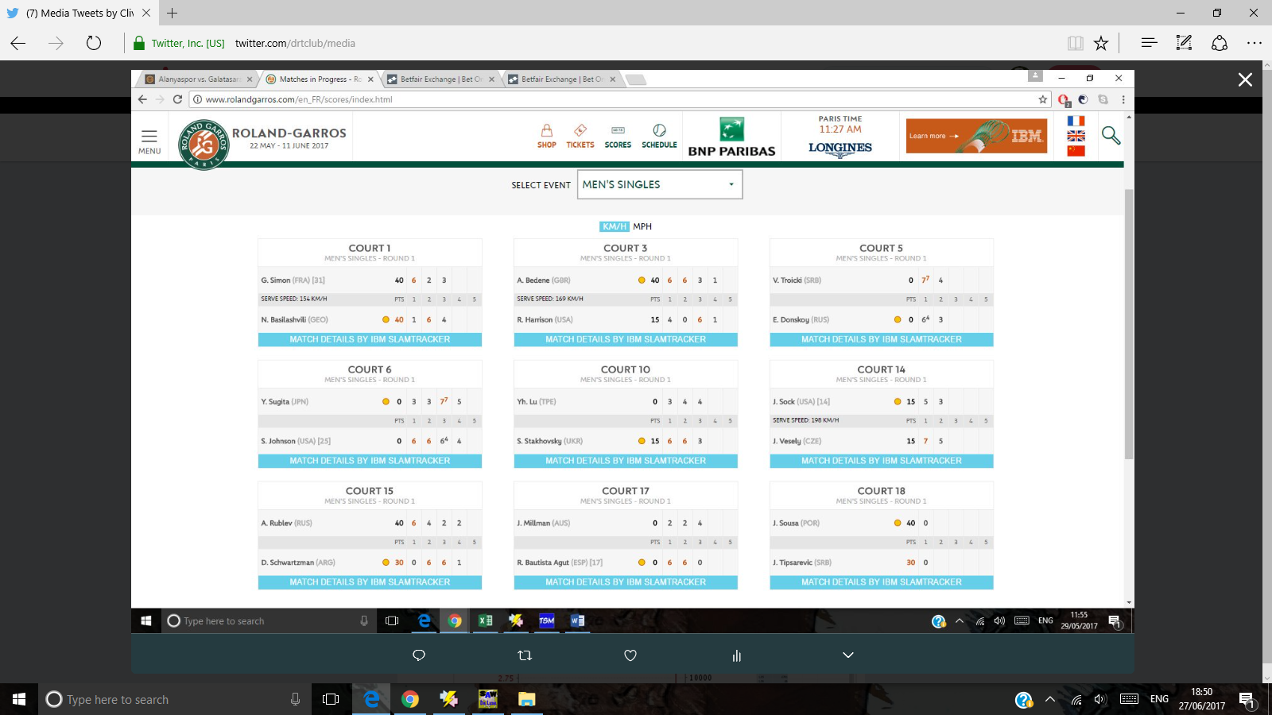

1. **[Clive Keeling](https://twitter.com/drtclub)**[‏Protected Tweets @drtclub](https://twitter.com/drtclub) [Jul 6](https://twitter.com/drtclub/status/883037495478427648" \o "11:58 AM - 6 Jul 2017)

More

* + Share via Direct Message
  + Pin to your profile page
  + Unpin from profile page
  + Delete Tweet

just for the record. 2-0 down sock 5-2 up 3rd set. 1.2 pre match

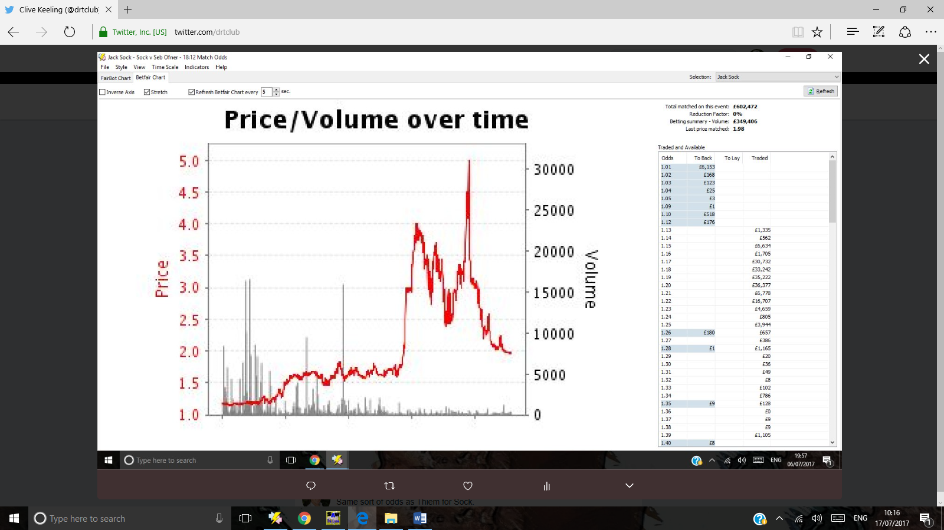

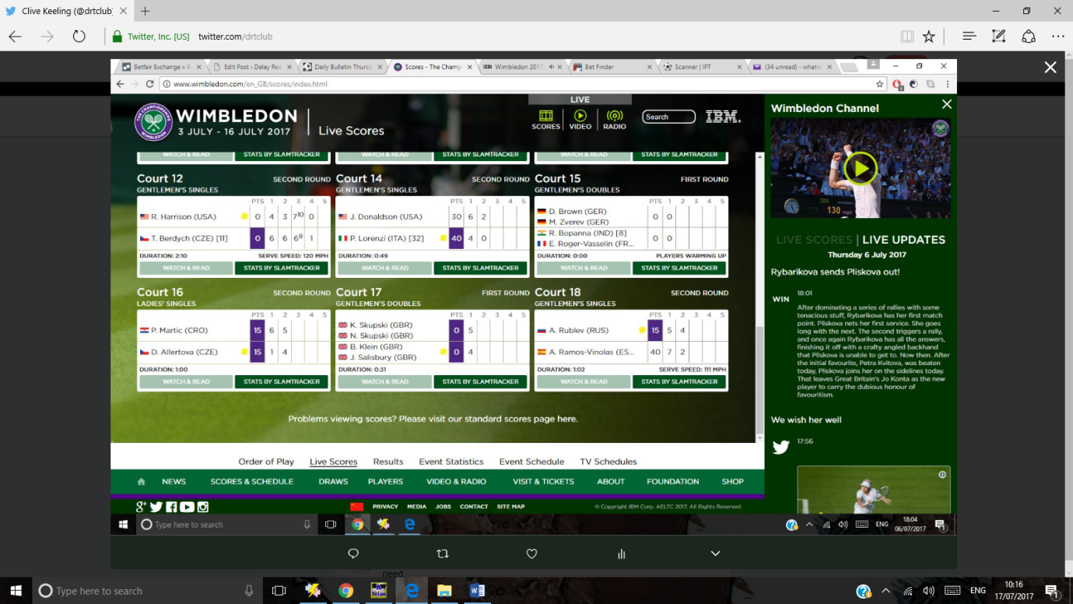

1. **[Clive Keeling](https://twitter.com/drtclub)**[‏Protected Tweets @drtclub](https://twitter.com/drtclub) [Jul 6](https://twitter.com/drtclub/status/883008807386927105" \o "10:04 AM - 6 Jul 2017)

More

* + Share via Direct Message
  + Pin to your profile page
  + Unpin from profile page
  + Delete Tweet

What do you see here? Another 2-0 to 2-1 in the men's game.

1. **[Clive Keeling](https://twitter.com/drtclub)**[‏Protected Tweets @drtclub](https://twitter.com/drtclub) [Jul 6](https://twitter.com/drtclub/status/882944021202710529" \o "5:47 AM - 6 Jul 2017)

More

* + Share via Direct Message
  + Pin to your profile page
  + Unpin from profile page
  + Delete Tweet

I'm getting the feck out of here. 1.05 lay nicely tucked away!! Thanks Kukushkin 1.50 out. Remember Zverev was 1.25 pre match

Zverev 2-0 up here. Well worth laying given the 2-0 to 2-1 phenomenon

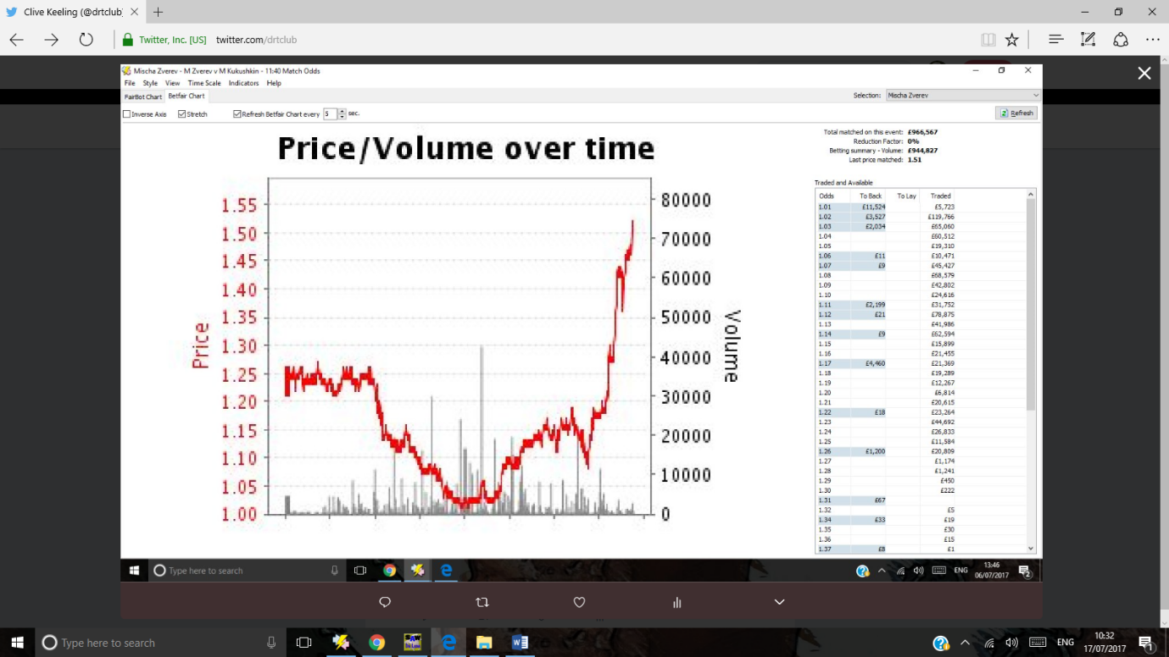

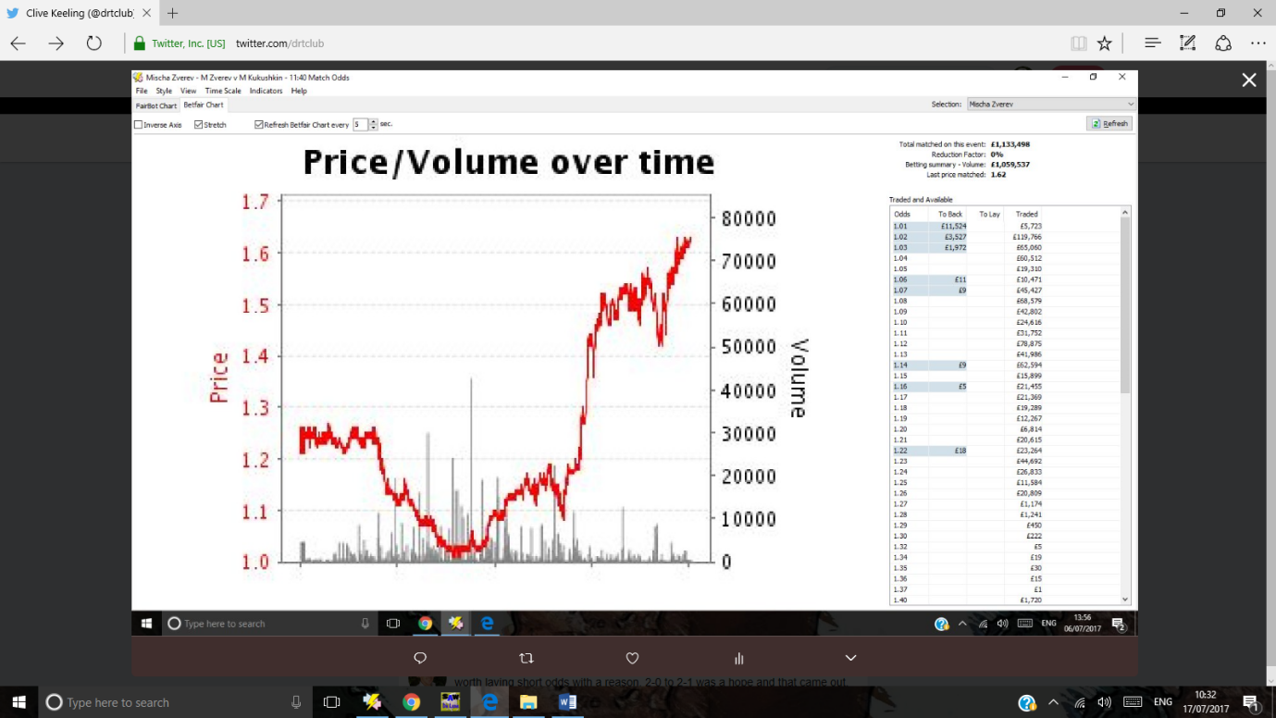

1. **[Clive Keeling](https://twitter.com/drtclub)**[‏Protected Tweets @drtclub](https://twitter.com/drtclub) [Jul 5](https://twitter.com/drtclub/status/882576392923303936" \o "5:26 AM - 5 Jul 2017)

More

* + Share via Direct Message
  + Pin to your profile page
  + Unpin from profile page
  + Delete Tweet

Agut. 2-0 to 2-1 scoreline. Happens a lot in grandslams. Could be a mental switch on for a player 2-0 down realising he is out with a loss

