ftp ELETTER

Profiting from Grand Slam Tennis.
Yes, we have our summer football leagues :
- Norway
- Sweden
- Finland
- Ireland
And the Euros are coming our way very soon. Next week sees a whole raft of International Friendlies. While we’re in a holding pattern waiting for the Euros to start, let’s go off tangent and look at a new sport.

During this spring/summer, please remember tennis. Football Trading Profits strategies can be applied to tennis, only in this case it’s sets that we are interested in, and not goals.

Here’s a look at some of the Green Screens I shared with you on Telegram. I hope these green screens help persuade you to take a look at tennis during the summer months and use it to supplement the football this season.

Here’s a fresh trade.

Fokina is the pre-match favourite. He concedes the first set. I thought that his odds ( 2.3) were very generous given his opponent’s rankings. As Fokina wakes up 2nd set, the odds start to move in our favour. We can make a guaranteed £20.08 profit before Fokina has even secured the set!

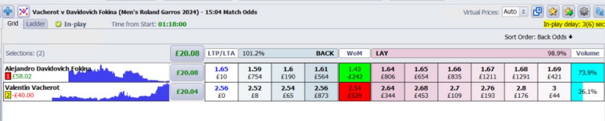
Note the following when you trade tennis :
- Who is the pre match favourite? Fokina at 1.20 ( decimal odds) is the favourite.
- Who has won the first set? In this match, Vacherot. As I said above, Fokina’s odds were very tasty with just one set down.
- Remember, Remember! In Grand Slam men’s tennis, it is the best of 5 sets so there is a long way to go when any underdog wins the first set.
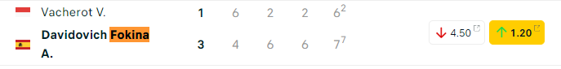

When in France…..take note of the French players.
Here are the odds for Richard Gasquet, France’s Darling, v Borna Coric. Coric is warm order. But what are we seeing? Richard Gasquet, who I jokingly compared to Joe Biden age-wise on Telegram, has won the first 2 sets.
Note the following :
- Both sets won by Richard Gasquet were tie breakers ( 7-6 tells you that the sets were very tight with Gasquet just winning the key points at the right time).
- As above, Remember it is the best of 5 sets. Any male player leading 2-0 in sets has not won the match yet! It is at the beginning of the 3rd set that you can either a) Lay Richard Gasquet or b) Back Borna Coric. The ideal time is to cash out if Borna Coric hints at winning the 3rd set.

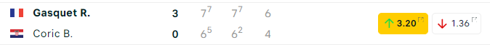

Play the Hint and Not the Outcome!
This is a key tenet of trading . It’s not the final result but what happens during the match that is key.

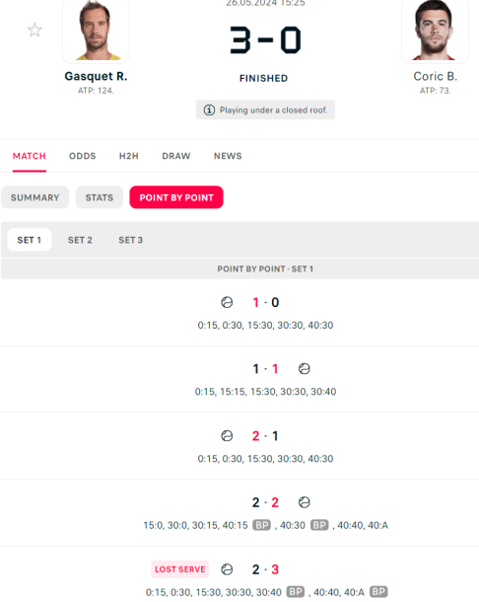
It was at this loss of serve, arrowed above, where we caught a glimpse that the market expected Coric could win the 3rd set. I took the opportunity to cash out. ( In fact, Coric lost his very next service match and lost the set but I still profited).

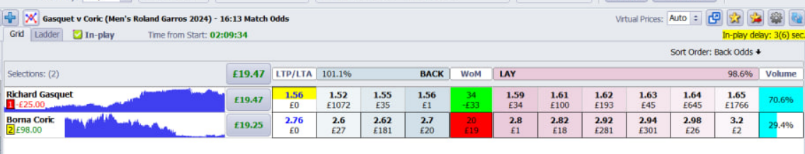

A Houdini-like escape.

Bai , in this match, is the underdog but has taken a commanding 5-2 lead in the first set . She only needed to win one game to secure the set. I decided to back the favourite WANG at good odds before the 1st set is secured. And boy did she pay me off! She turned a 5-2 into a 6-5 lead.
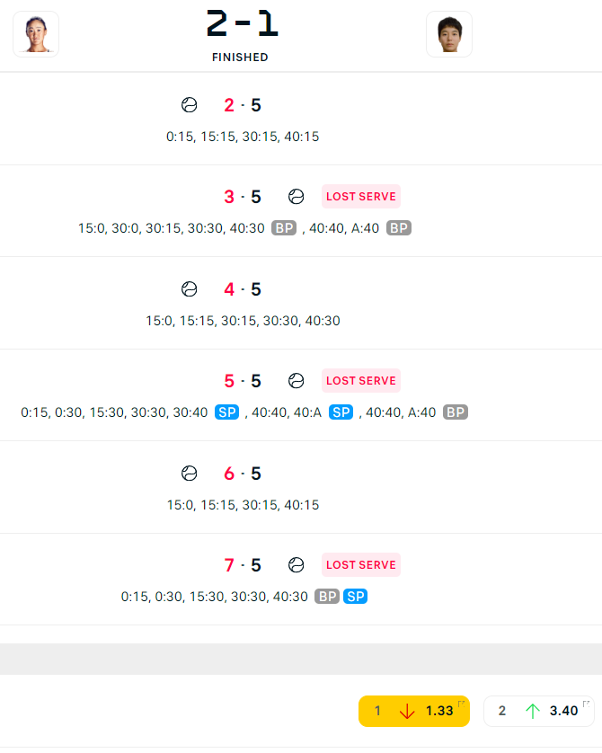
Look at that turn around! Spectacular. Back Wang 5-2 down .
And a nice profit. I do like to get involved before the first set is concluded. In a case like this, you can be out with a solid profit before the set is even over.
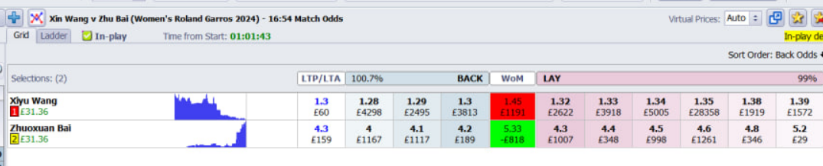

Like Gasquet, take note of the locals.
In this instance, Caroline Garcia is the French Darling. Her opponent Lyn is not reading the script. Lyn wins the first set. I back Garcia then. Garcia wins the next set for a nice green screen.

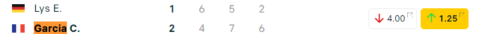

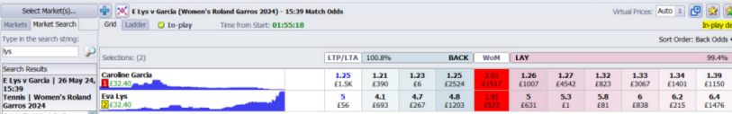

I have uploaded some tennis articles for you at www.footballtradingprofits.com if tennis is something you want to add to your roster ( and why not - look at the green screens!). Just remember with tennis that it’s sets we are interested in. Next week’s eletter will take a look at the Euros. We’ll be checking out the market favourites and their chances and look at the upcoming schedule of matches and ways to make money.

