Alexander Zverev v Fernando Verdasco - Madrid Masters 2017

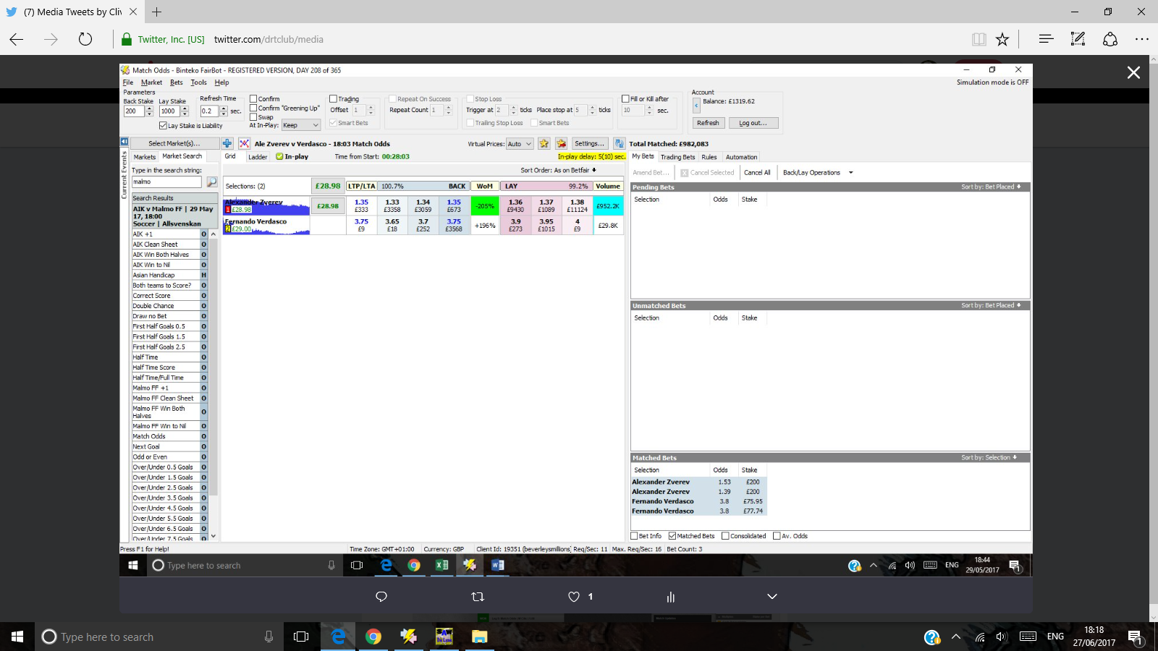

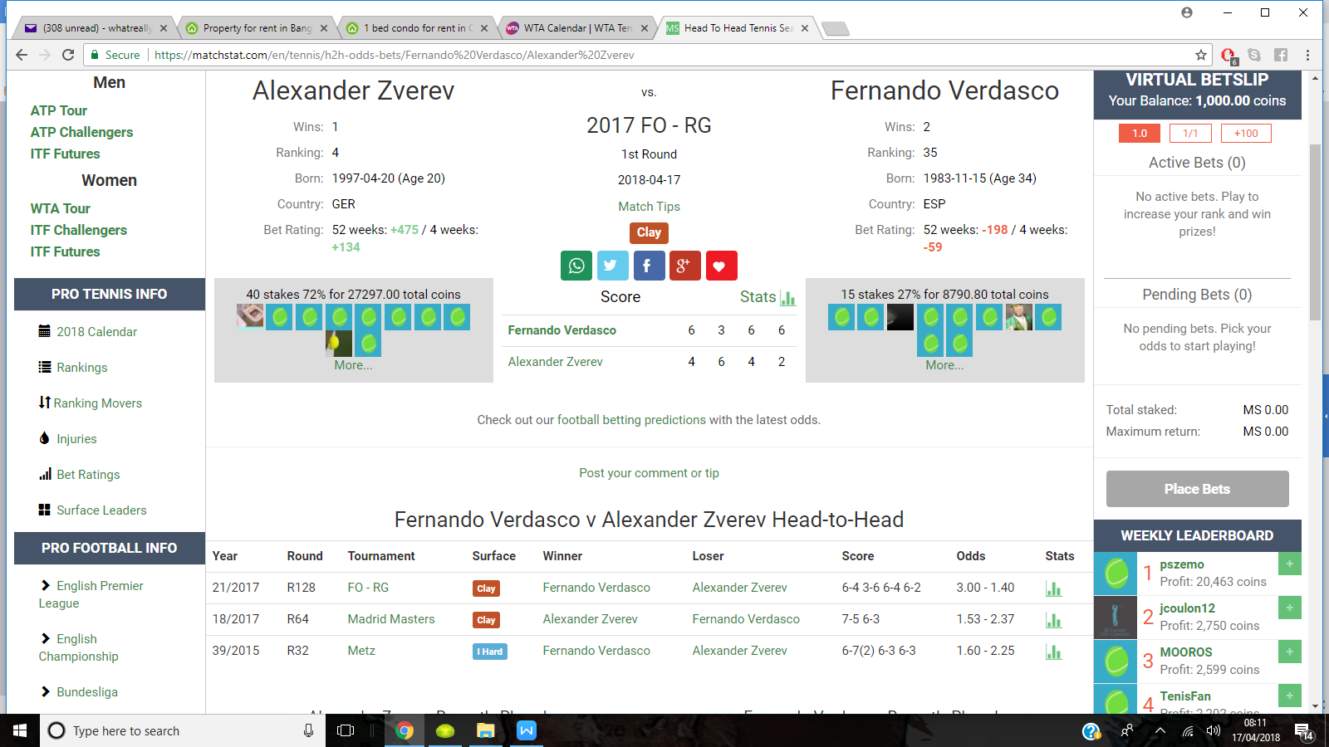

Milos Raonic v Tomas Berdych - Rome Masters

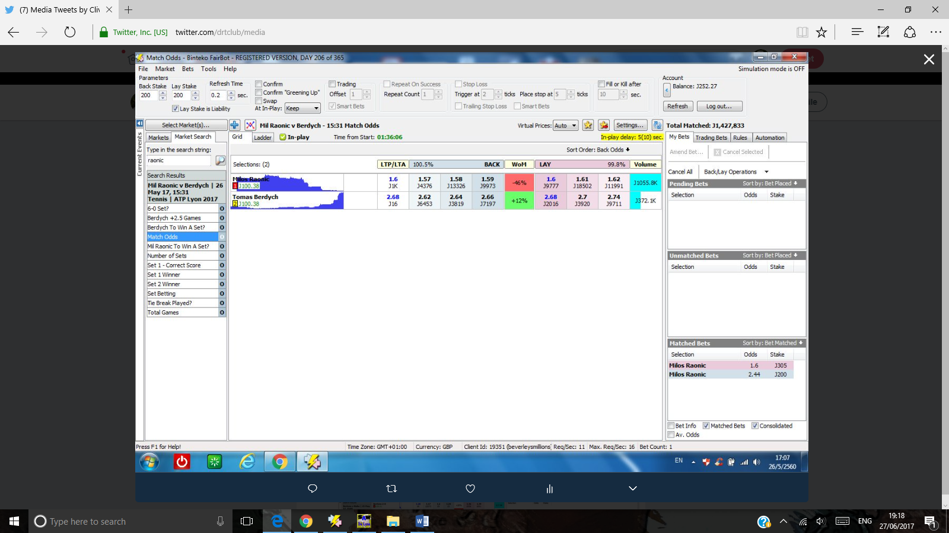

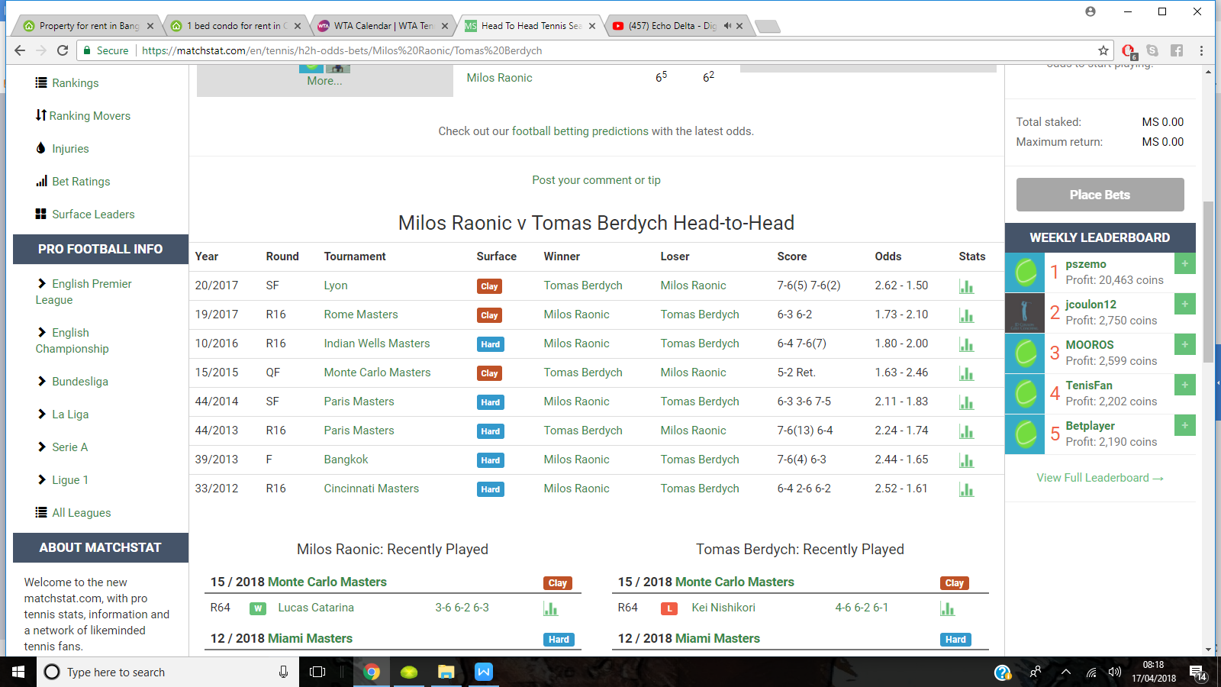

May 26th

Quentin Halys v Juan Martin Del Potro

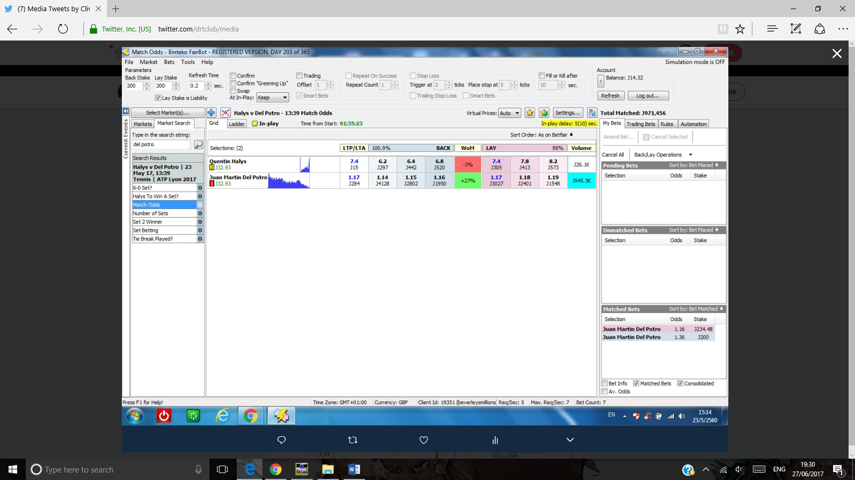

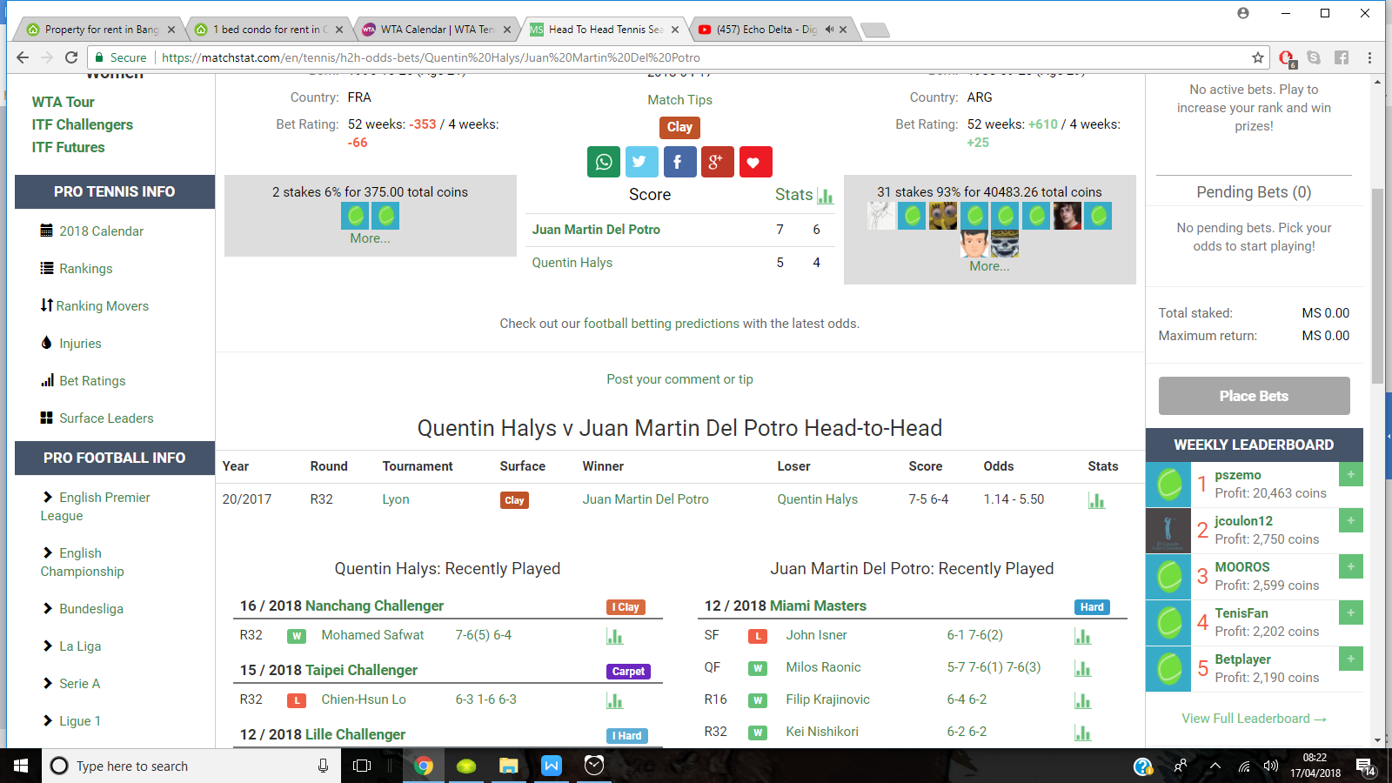

A quick move as Halys threatened in the first set. Del Potro’s odds drifted relatively high to 1.36 and soon dropped to 1.16

23rd may

Jan-Lennard Struff v Cedrik-Marcel Stebe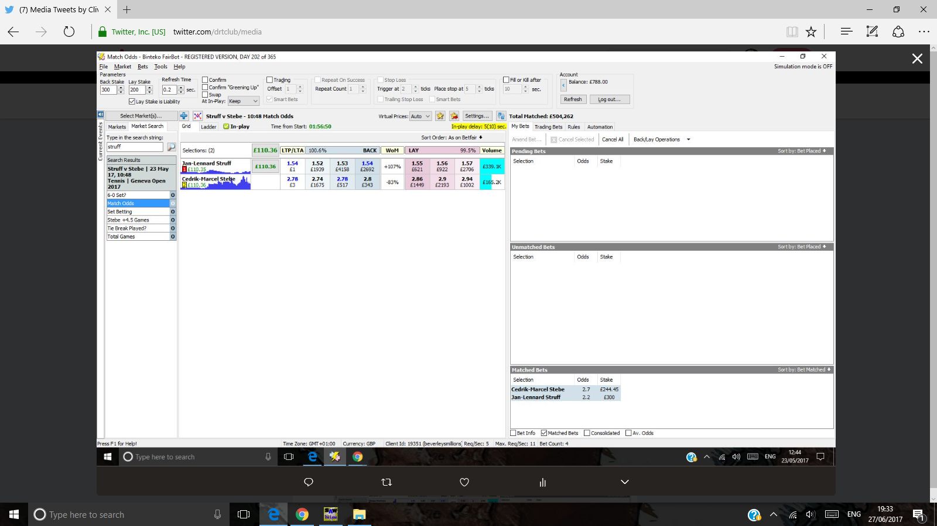

20/2017 R32 Geneva Clay Cedrik-Marcel Stebe Jan-Lennard Struff 6-3 4-6 7-6(2) 5.00 - 1.17

1.17 favourite Struff won the first set, lost the 2nd set and struggled in the 3rd set, so much so that his odds drifted to 2.2 . Trade out at 1.55 lay of Struff or 2.7 back of Stebe to return liability.

May 23rd

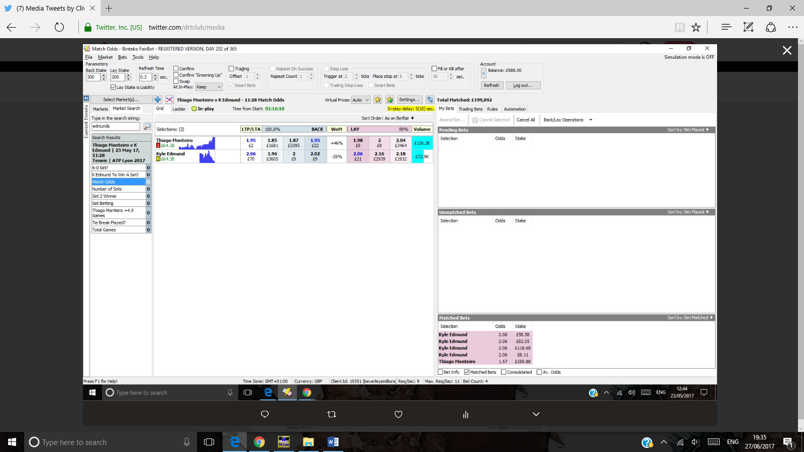

20/2017 R32 Lyon Clay Kyle Edmund Thiago Monteiro 2-6 6-4 6-1 1.36 - 3.00

Strong favourite Edmund loses the first set. I lay Thiago Monteiro at 1.57 odds expecting a come back 2nd set and it came , enough to engineer a profit.

May 23rd

1. **[Clive Keeling](https://twitter.com/drtclub)**[‏Protected Tweets @drtclub](https://twitter.com/drtclub) [Jul 6](https://twitter.com/drtclub/status/882962323991867392" \o "6:59 AM - 6 Jul 2017)

More

* + Share via Direct Message
  + Pin to your profile page
  + Unpin from profile page
  + Delete Tweet

I can't take any more! I am out. Aggy may yet pull it off but these are 2 out of form players.

McHale v Radwanska

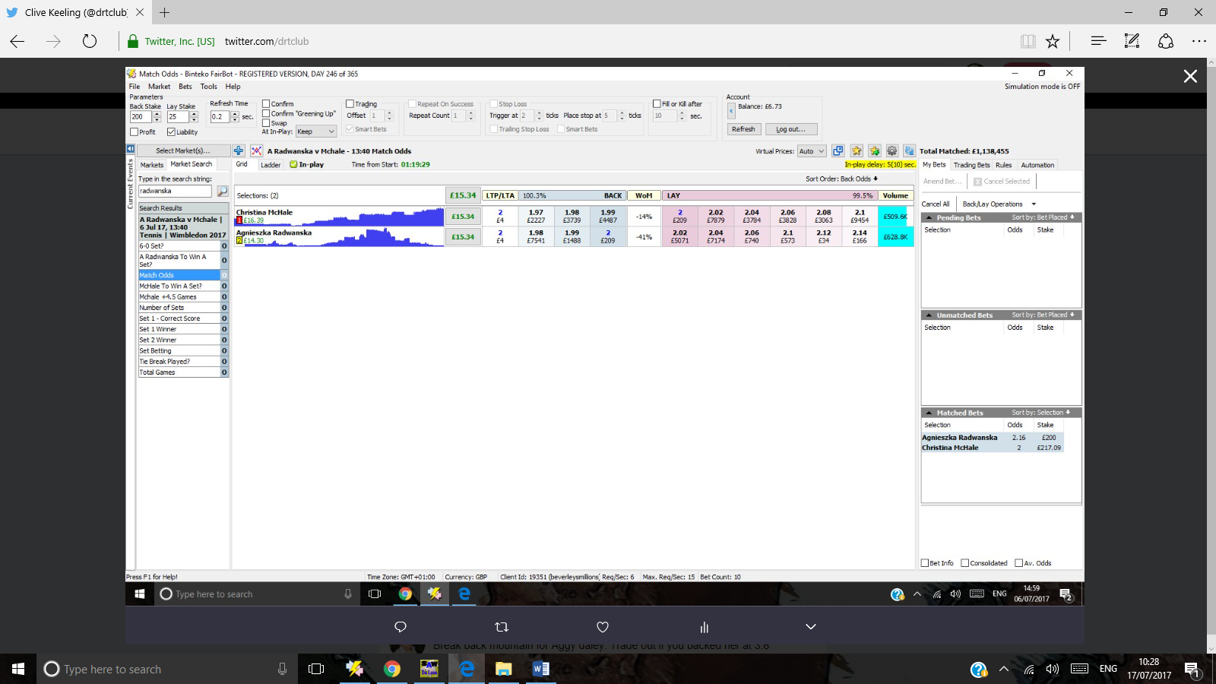

27/2017 R64 Wimbledon Grass Agnieszka Radwanska Christina McHale 5-7 7-6(7) 6-3 1.30 - 3.50

1.3 favourite Radwanska loses the first set and it was tight at 5-7. She won the 2nd set in a tiebreak and was available to back at odds of 2.18 . I bottled out of this, such was her difficulty in ensuring a 2nd set win in a tie breaker. She did go on to win so those more hardy than me would have seen a greater profit

Wang v Williams

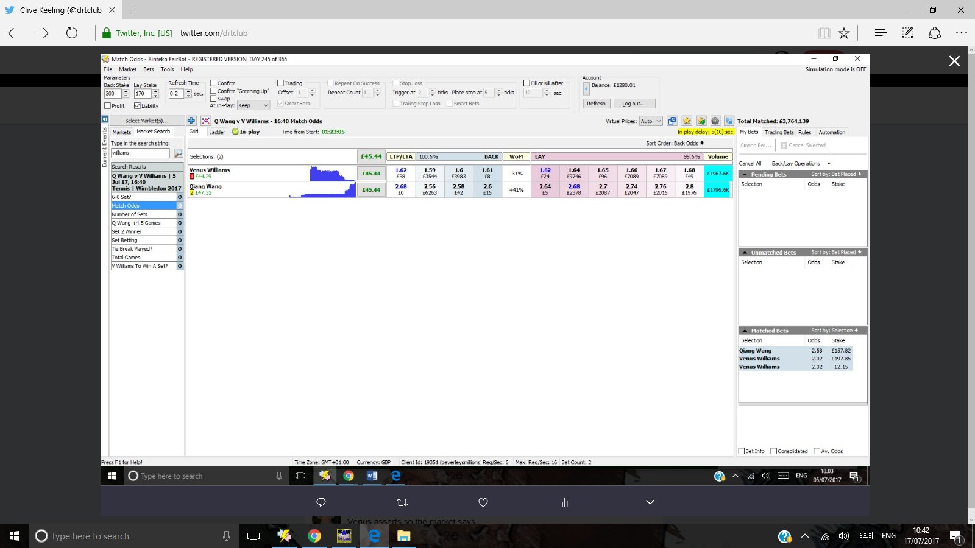

27/2017 R64 Wimbledon Grass Venus Williams Qiang Wang 4-6 6-4 6-1 1.19 - 4.40

Strong favourite Venus Williams loses the first set and is backable at 2.02 odds and higher. She wins the 2nd set and the 3rd set to guarantee her odds shorten and a profit is secured.

1. **[Clive Keeling](https://twitter.com/drtclub)**[‏Protected Tweets @drtclub](https://twitter.com/drtclub) [Jul 5](https://twitter.com/drtclub/status/882646052465233920" \o "10:03 AM - 5 Jul 2017)
2. Thiago Monteiro v Karen Khachanov

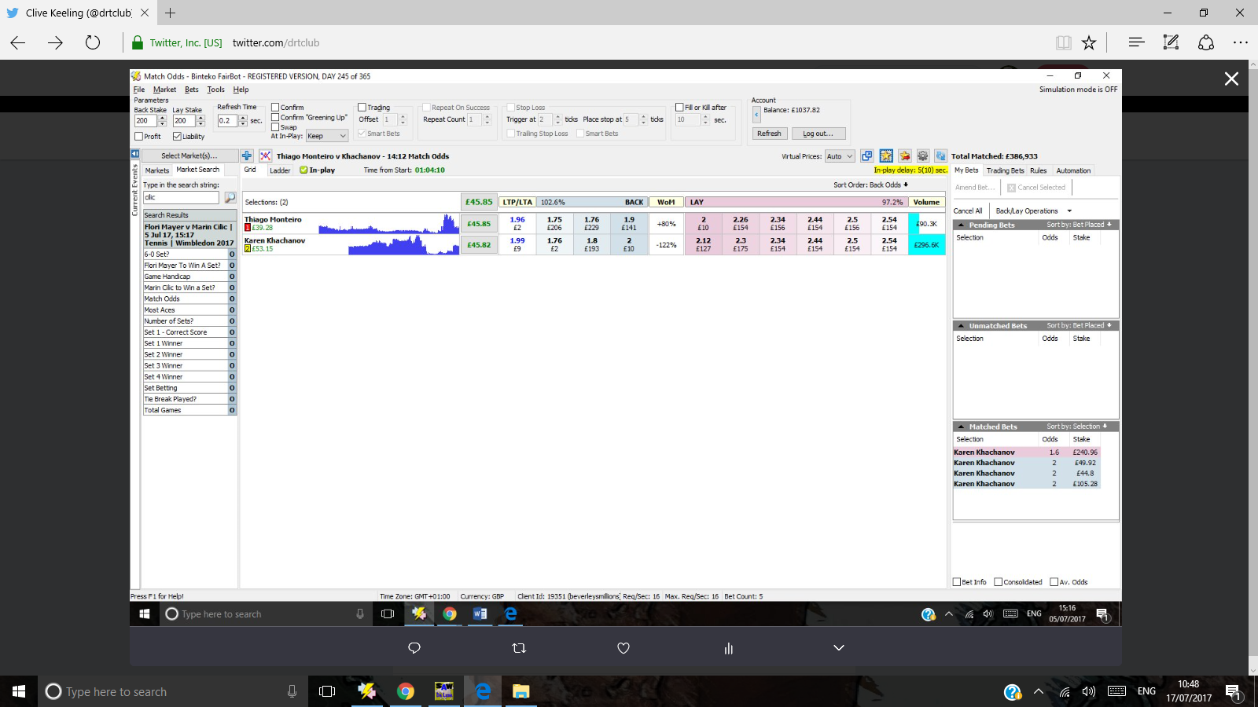

1. **[Clive Keeling](https://twitter.com/drtclub)**[‏Protected Tweets @drtclub](https://twitter.com/drtclub) [Jul 5](https://twitter.com/drtclub/status/882604038998691840" \o "7:16 AM - 5 Jul 2017)

More

* + Share via Direct Message
  + Pin to your profile page
  + Unpin from profile page
  + Delete Tweet

Karen - woman's name, men's player. Green screen.

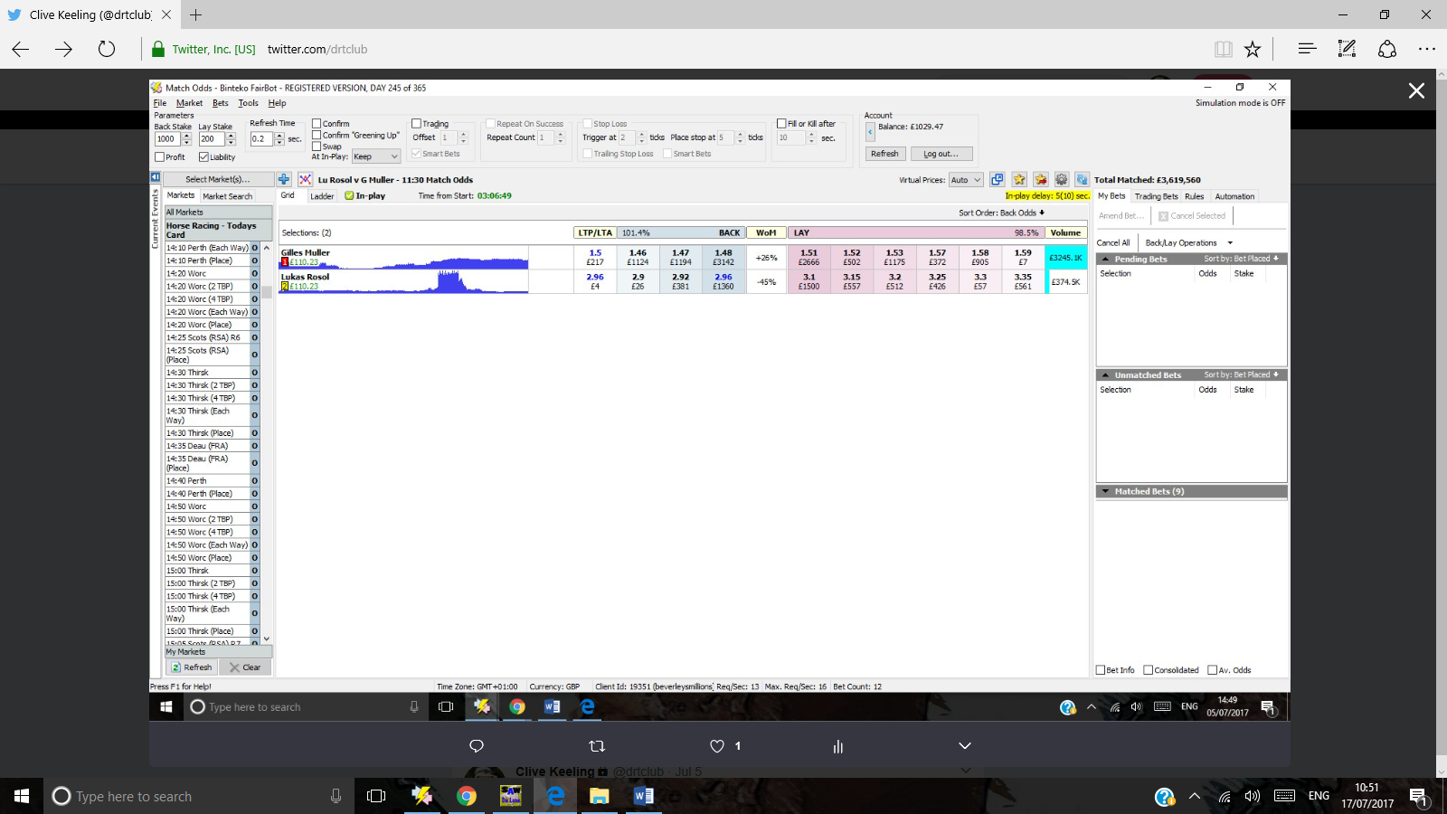

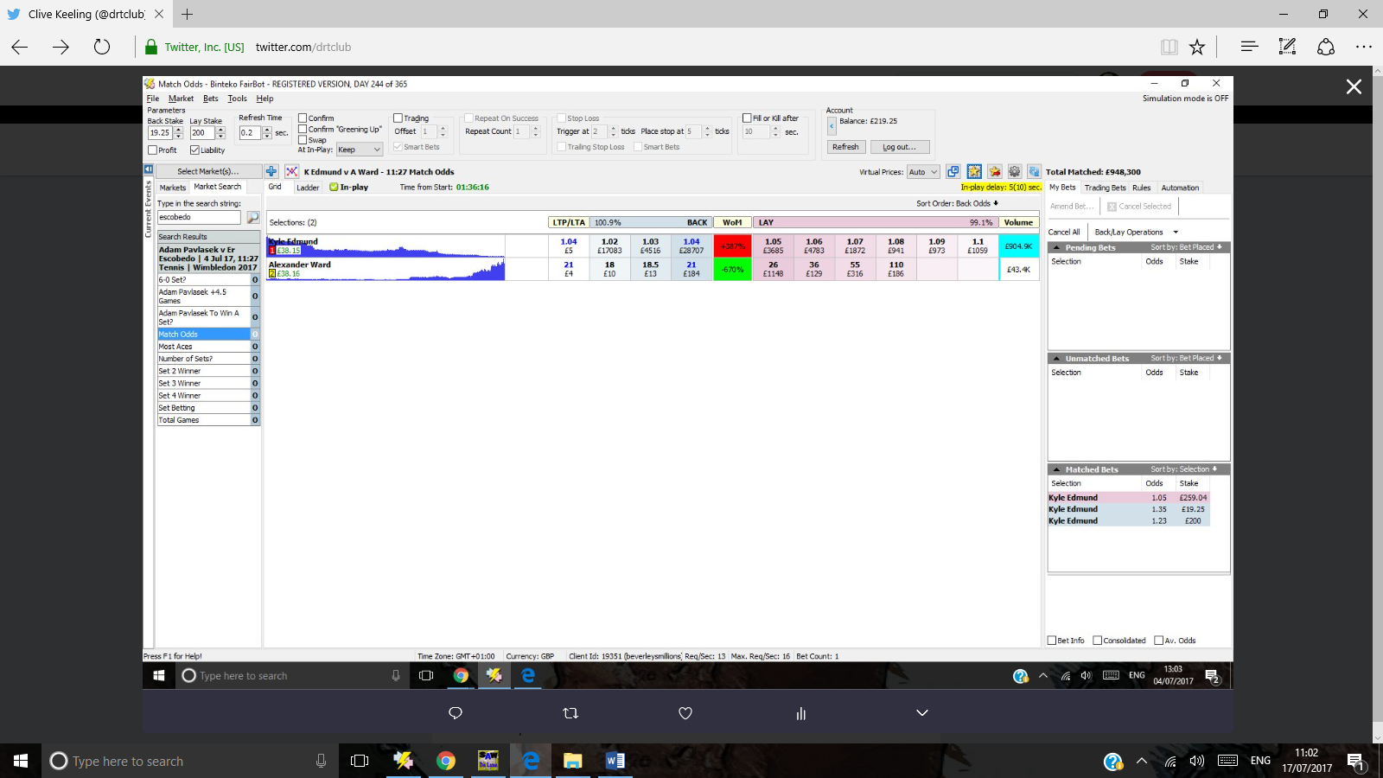

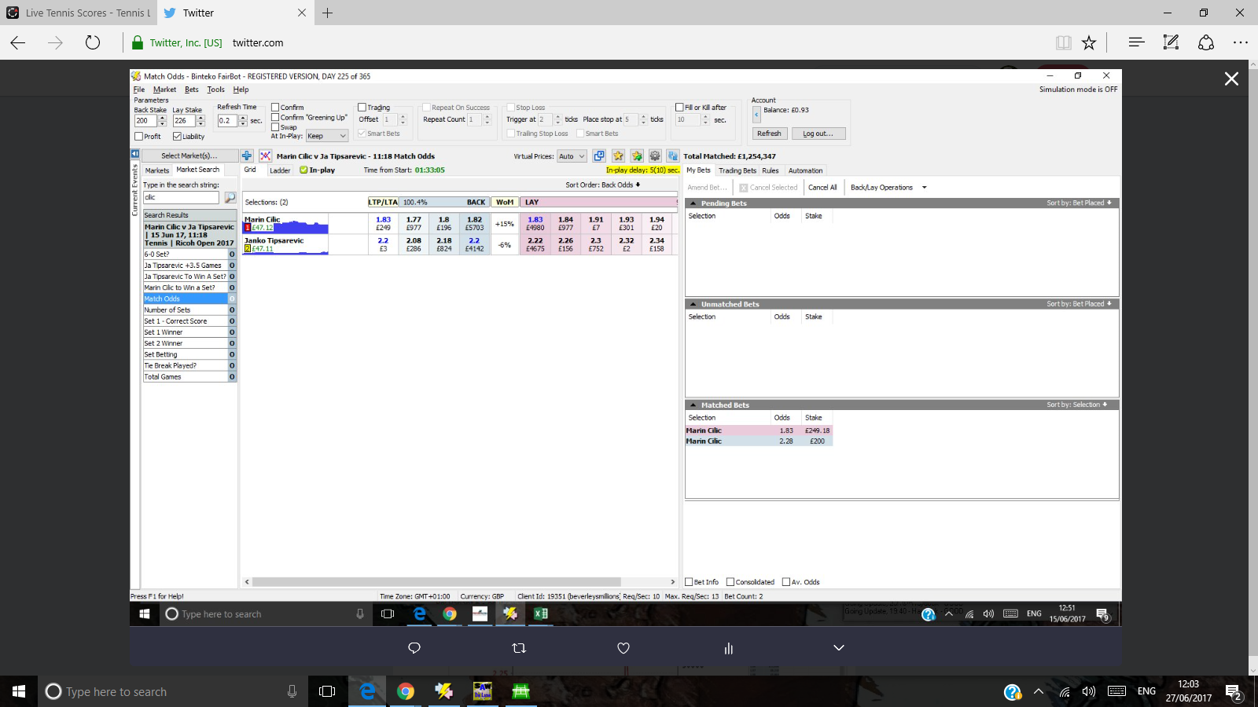

Cilic v Tipsarevic

June 15th

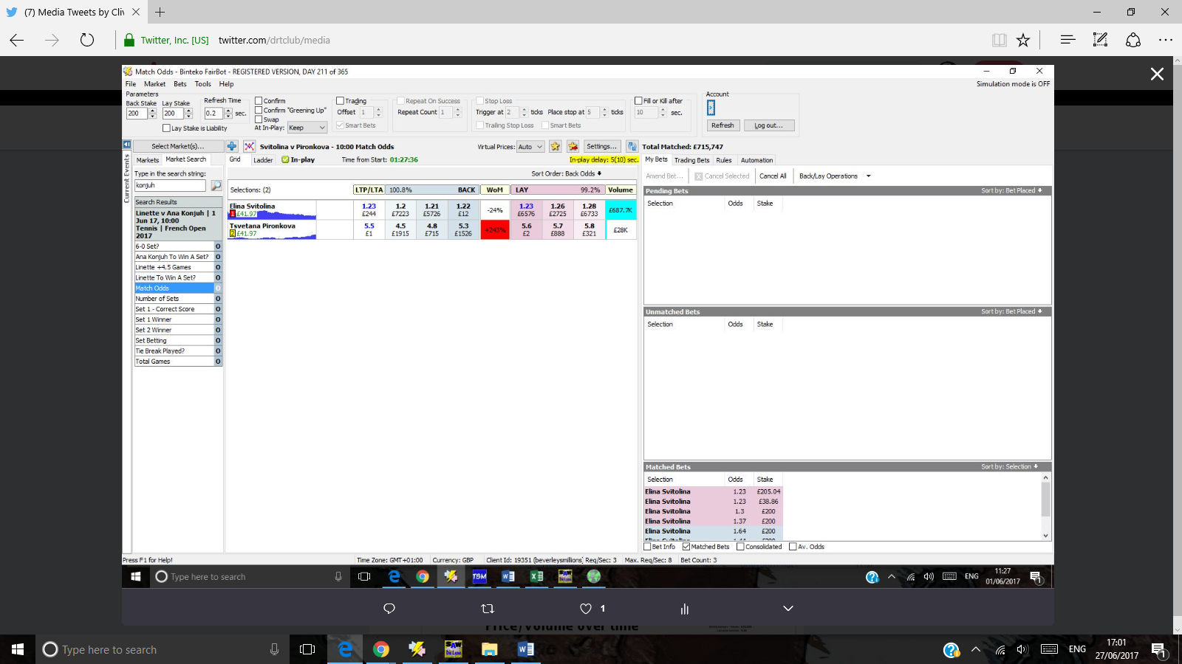

Green screen june 1st